“DEVELOPMENT AND VALIDATION STABILITY INDICATING RP-HPLC AND UV SPECTROPHOTOMETRIC METHOD FOR DETERMINATION OF LENALIDOMIDE IN BULK AND TABLET”
A Thesis submitted
In Partial fulfillment of the requirements
For the Degree of

MASTER OF PHARMACY
In
PHARMACEUTICAL CHEMISTRY
By

ASHUKA SINGH
Enrollment No. 201020050072230
Under the Supervision of
DR. ROHIT TRIPATHI
(PROFESSOR)
SHAMBHUNATH INSTITUTE OF PHARMACY, JHALWA, PRAYAGRAJ

To the
FACULTY OF PHARMACY
DR. APJ ABDUL KALAM TECHNICAL UNIVERSITY
(Formerly Uttar Pradesh Technical University)
LUCKNOW
OCTOBER, 2026

ABSTRACT

A swift, exceptionally sensitive high-performance liquid chromatography were established for fortitude of Lenalidomide in bulk API also in capsules. Lenalidomide was isolated from a Inertsil C8 reversed-phase by a mobile phase that is 7:3 CH₃OH and water with a pH of 9 and I mWmin flow rate with UV revealing at 395 nm. The period of retention
for Lenalidomide was 6.64 ± 0.05 min. The response (r² = 0.9991) was noted in between 2 - 12 gg/mL with LOD and LOQ being 0.13 and 0.39 gg/ml, accordingly. The technique demonstrates solid recoveries, with relative SD of less than 2.0% both within and between days. We also calculated validation parameters like robustness, specificity, and accuracy. Lenalidomide, both in bulk and in capsule dosages, can also be consistently and accurately analyzed using the suggested method, which serves as a quality control tool.

Keywords: Lenalidomide, Method Development, RP-HPLC, Method Validation, ICH
Guideline.

CHAPTER -1
INTRODUCTION

Introduction
1.1 Analytical Chemistry
Analytical interaction is amongst key chemistry branches implicated in the division, recognition also estimation of components of organic and synthetic substances. Advanced analytical chemistry involves the separation besides identification of chemical substances by intends of several techniques (chromatography, spectroscopy and electroanalytical). Analytical chemistry is used to guarantee quality and purity in the pharmaceutical industry and to track pollutants in the air, aquatic and soil in environmental science. The field is also very important in fields of food safety, forensic science and material science, enabling information about the composition and properties of substances. As chemistry evolves, analytical chemistry continues to develop new methods and techniques that help scientists understand complex chemical systems, driving innovation in the field and its applications in industries all over the world. Analytical chemistry constitutes a fundamental discipline of chemical sciences which pertains to careful, accurate analysis of chemical substances. This employs advanced methods and apparatus that allow the separation, identification and magnitude of matter, even in the most complex mixtures with the utmost accuracy. The chemical composition of samples like pharmaceuticals, environmental contaminants, food products and forensic materials are usually analyzed using analytical techniques like HPLC, GC, and MS.
Analytical chemistry is crucial for pharmaceutical field, playing a critical task in the improvement of new medicines by conducting detailed testing and quality control processes to ensure their effectiveness and safety. Analytical techniques are used by environmental scientists to identify and quantify pollutants, which is important in protecting ecosystems and human health. To ensure the food product is pure and safe, and meets nutritional requirements, these techniques are used by food scientists. Analytical chemistry is used in forensic science to analyze evidence found at a crime scene to help solve a case.
It also involves novel analytical methodologies creation also refinement of current ones, as technology evolves and the knowledge and understanding of chemistry continues to grow. The innovations increase the sensitivity, specificity and speed of analysis, thus expanding the range of the analysis and detection possibilities. Analytical chemistry is closely related to several scientific and industrial fields, and numerical and descriptive data it affords fundamental to knowledge progress, to safety and to innovation. Analytical chemistry lies at the core of both scientific research and industrial application, and serves as the link between theory and practice. It includes many techniques which enable scientists to explore the molecular and atomic structure of a substance and give them an important clue to its composition and properties. Methods such as chromatography (including GC & LC) help to separate complex mixtures into their component parts, allowing the individual components to be identified and quantified precisely.
Spectroscopic techniques, including UV-Vis, NMR, IR spectroscopy, use light to gain detailed knowledge on structure along with molecular dynamics. MS extremely useful for recognition of unknown compounds and elucidation of chemical structure because it allows determination of m/z ratio. The electroanalytical methods grounded on the measurement of electrical characteristics for analysis of chemical substances (potentiometry, voltammetry) have high sensitivity and selectivity.
Analytical chemistry plays an important role in environmental science for monitoring pollutants and in evaluating the health of the environment. It helps to detect trace amounts of contaminants in air, water and soil which helps to safeguard human well-being and ecosystem. In the pharmaceutical sector, precise analysis is crucial for maintaining high-quality, safe, and effective drugs, both in their development and production stages. Analytical chemists develop methods for the detection of impurities, verification of the composition of active ingredients and compliance with regulatory standards.
Analytical chemistry has a crucial role in food and beverage industries in quality control and safety assurance. Analytical techniques are employed to identify contaminants, to confirm the claims on products and to ensure that products comply with nutritional requirements. Analytical methods are key in forensic science, as they must be precise and reliable to analyze evidence, ranging from determining what substances are present to connecting suspects to crime scenes.
Analytical chemistry is a dynamic and rapidly developing field of chemistry with the new development of the technology and methodology. Analytical chemists are seeing some exciting innovations, including high-resolution mass spectrometry, microfluidics and lab-on-a-chip devices, that allow scientists to analyze more quickly, sensitively and thoroughly. These innovations not only propel a better understanding of the world, but they also have real-world applications that boost the quality of life, ranging from improved health care solutions to better environmental monitoring. Overall, analytical chemistry plays a fundamental role in science and industry, enabling the investigation, understanding and manipulation of chemical substances. It's essential in many industries, contributing significantly to progress and safety, effectiveness, and compliance in diverse applications. Instrumental analytical techniques are also some of the most crucial tools that have been used in the modern-day analytical chemistry which enable the precise and accurate analysis of chemical substance. These techniques are used to split up, identify and measure components in a range of samples, making use of sophisticated instruments.

Advantages
- Elevated sensitivity is obtained
- Small sample can be utilized
- Reliable measurements
- Fast tenacity
- Capable of analyzing complex compounds and easy to handle.

Limitations of instrumental methods
- High cost of instruments and maintenance
- Requirement of skilled and trained personnel
- Need for regular calibration and validation
- Dependence on electricity and controlled laboratory conditions
- Possibility of instrumental errors and interference
- Complex sample preparation in some techniques
- Limited portability for certain sophisticated instruments
- High consumption of solvents, reagents, and consumables
- Time-consuming method development and optimization
- Sensitivity to environmental conditions such as temperature and humidity

Principal kinds of instrumentation
- Spectrometric practices
  - Phosphorescence & Fluorescence spectroscopy
  - UV-VIs
  - IR spectroscopy
  - Atomic spectroscopy involving emission and absorptions measurements
  - X-ray spectroscopic methods
  - Raman spectroscopic analysis
  - Radiochemical analytical methods, comprising activation testing
  - NMR
  - ESR

Electrochemical Techniques
  - Potentiometry
  - Voltametric techniques
  - Amperometric measurements
  - Stripping analysis methods
  - Colorimetric analysis
  - Electrogravimetry methods
  - Conductometric technique

Chromatographic Techniques
  - HPLC
  - GC
  - HPTLC
  - TLC

Miscellaneous Techniques
  - Mass spectrometric analysis
  - Thermal analytical techniques
  - Kinetic-based analytical methods

Hyphenated Practices
  - GC-MS
  - GC-IR
  - MS-MS
  - HPLC– MS
  - LC–MS–NMR
  - LC–MS/MS
  - LC–NMR
  - CE–MS
  - Analytical Method development
The development of the method has been completed.
- for novel offerings
- for current offerings
If an official procedure is not available, analytical methods are developed for newly introduced products. For currently available non-pharmacopeial items, alternative methods intended to enhance accuracy also robustness, and to decrease the analysis time and cost. Each of these methods is validated using trial experimentation, optimized and then validated. Where a new method is suggested as an alternative to an accepted one, comparative laboratory information outlining merits and drawbacks is also included.

Selection of analytical method
The method of analysis chosen is an important decision to make for precision and reliability of analytical findings. Opting for most appropriate technique or set of techniques to fulfill the goals of the analytical problem is a matter of choosing, with respect to a number of considerations, the technique or techniques that best accomplish the goals:

Objectives of the Analysis:
    - o Identify if the goal is to be qualitative, quantitative, or both. This will affect the method/technique chosen.

Nature of the Sample:
    - Sample Matrix: Determine the complexity of sample matrix and interferences. Complex matrices may need to be treated with a method that is capable of dealing with them, like solid-phase as well as liquid-liquid phase separation extraction.
    - Chemical and physical characteristics: Take volatility, polarity and solubility into account. Gas chromatography (GC) is good for unstable substances and HPLC good for polar components.

Analytical Requirements:
    - Detection Limits: Determine sensitivity for the recognition and quantification of analytes at desired extent. There are methods such as mass spectroscopy which can be managed for the finding of traces with more sensitivity.
    - Accuracy and Precision: Make sure that the technique is dependable and can be replicated. This includes providing the method with a strict test and calibration.

Instrumental Capabilities:
    - Availability: Consider the availability of the required instruments and equipment. Choose methods that can be performed with the resources and technology available.
    - Expertise: Ensure that the analytical personnel are trained and proficient in using the chosen technique.

Practical Constraints:
    - Cost: Evaluate the cost of the method, including the expense of equipment, reagents, and maintenance. Balance cost against the required performance and accuracy.
    - Time: Consider the time required for sample preparation, analysis, and data processing. Some methods may be faster or more efficient than others.

Regulatory and Compliance Considerations:
    - Standards and Guidelines: Make sure that the method meets industry regulations and standards, including those established by the FDA, EPA, or ISO. Adherence to these standards is crucial for quality assurance and regulatory approval.

Method Development and Optimization:
    - Development: Customize and optimize the method to fit the specific requirements of the analysis. This may involve adjusting parameters such as thermal, flow rates, and detection wavelengths.
    - Validation: Conduct method validation to confirm its suitability for the intended application. This includes testing for accuracy, precision, specificity, and robustness.
By systematically evaluating these factors, analysts can select the most proper analytical method that meets the individual needs of their analysis, ensuring high-
quality, reliable results that support informed decision-making and compliance with relevant standards.
To undergo final optimization prior to transfer in order to validate its properties, including precision, sensitivity, accuracy, ruggedness etc. To evaluate medications samples in bulk, pharmaceuticals also biological fluids, various analytical techniques are frequently employed. Both classical and instrumental approaches are utilized to describe these analytical techniques.
Instrumental analytical techniques are generally easier to perform, more accurate, and more reproducible than conventional classical methods. Consequently, analytical procedures developed using advanced instruments like spectrophotometers, HPLC, HPTLC, and GC are widely utilized for both quantitative also qualitative assessment of raw materials as well as finished pharmaceutical products.

Steps of method development
- Characterization of the analyte standard
- Defining the method requirements
- Review of literature and existing methodologies
- Selection of an appropriate analytical methods
- Instrument setup also preliminary study
- Method optimization
- Analytical documentation of performance characteristics
- Assessment of developed technique using genuine specimens
- Ascertainment of percentage recovery from the sample matrix
- Analytical method validation

CHROMATOGRAPHY
Separation, identification as well as purification of the constituents present in composite mixture are done with one of the significant analytical technique-chromatography. The components of the mixture may differ in size or molecular weight. Both quantitative as well as qualitative analysis are performed with chromatography for components in complex combination. Chromatography is not only science but also art in separating analytes existing as complex mixtures. It includes the process of physical separation that yields individual components of interest. However chromatographic technique is only applicable if the components are just mixed together physically, in case of chemically combined elements separation, identification and quantification may not be viable.

Principle of Chromatography
The basic principle involved in chromatography is stationary phase (it may include fluid stationary phase) or solid surface phase onto or into which the mixture containing components, molecules or substances to be separated are applied with the aid of mobile phase that moves from one end to other of stationary phase. The fact of separation is governed with many factors like molecular characteristics associated to adsorption of components, molecular weight, partition coefficient as well as affinity of elements under study and which are being separated. The variation in the size or molecular weight of individual element in the mixture results in retention of some components and they move gradually through system whilst others are moving rapidly with moveable phase along with departing quickly from the system.

Terminology Employed in Chromatography

Mobile Phase
Moving part in chromatographic system is termed as mobile phase, generally specimen is solubilized in the transportable phase. The amalgam of mobile phase consists of liquids, gases, even supercritical fluids. It is necessary and of significant value that components under study that are being separated should always be compatible with mobile phase.

Stationary Phase
The stagnant phases over which mobile phase is mandated to move is referred to as stationary phase. The composition of the static phase includes solid stand, sometimes liquid layer placed on solid support surface.

Supporting Medium
A firm substrate upon which the static phase resides either in the form of layer or liquid spread referred as basis for the medium. Assuming that the transit time is permitted to move on it distribution of analytes between two phases occurs on the basis of partition coefficient or affinity.

Elute
After completing the chromatographic procedure, the component obtained is referred as elute.

Eluent
The part of mobile phase that acts as carrier is eluent. The movement of analyte among chromatographic apparatus is governed by eluent.

Elution
Under the influence of moving solvent, the event of extracting absorbed component or substance is referred to as elution.

Chromatogram
A graphical representation of responses of graphical representation of detectors based on elution time, band location, morphology, and resolution are referred to as a chromatogram.

Retention Time
The following injection of duration for each solute to arrive at the detector within the column is indicated to as Rt (retention time).
CHROMATOGRAPHY TYPES
Derived from Characteristics of Mobile Phase:
Liquid Chromatography
This analytical technique includes mobile phase in the form of liquid solvent employed in separation of elements or components present in liquid samples. It also consists of stationary phase as column that contains solid beads.

Gas Chromatography
The major application of this technique is separation of sample vaporization assisted by a carrier gas acting as a mobile phase while the stationary phase composed of column containing liquid or solid beads.

Paper Chromatography
In this technique the paper strip utilized as stationary phase while it is employed in separation of dried liquid trials using liquid diluents as “Mobile (movable) Phase”.
TLC
This technique uses glass plates protected with very fine layer of silica or alumina gel while liquid solvents served as mobile phase which are employed in separation of dried liquid samples.
Based on the Mechanism of Separation Partition Chromatography
Separation occurs based on variation in partition coefficients of components or substances under study in this kind of chromatography. Distribution between two mobile phases is not uncommon and occurs due to diversity in partition coefficients. Even the partition of molecules enters the stationary phase due to a preference for stationary phase finally it again elutes in mobile phase.

Adsorption Chromatography
As the name indicates this type of chromatographic method is basis on adsorption. The substances are separated based on interaction between adsorbate and adsorbent. The solid surface acts as adsorbent while the components in the mixture served as adsorbates that are likely get attached to stationary phase. The concept of adsorption chromatography much like partition chromatography. The components under study are adsorbed on the solid or stationary surfaces.

Ion-Exchange (IE)
In this sort of chromatography, the separation of polar ions is done depending on affinity they have for ion exchangers which served as stationary phase. Molecules possessing any kind of charge like small nucleotides, larger amino acids, proteins are separated using ion-exchange chromatography. Either anions or cations are separated by means of ion-conversation chromatography. The relative strength of ionic bond affects the separation by IE chromatography.

Molecular Exclusion Chromatography
It is alternatively known as size exclusion &/or gel permeation chromatography. The procedure separation is observed on basis of size or molecular weight of component under study. The mechanism of separation involves filtration through gel where it served as stationary phase. This gel comprised of hetero porous cross-linked polymeric beads. Molecules with smaller size get trapped into the pores while the molecules with larger size avoid entering the pores and able to run greater distance in gel. The retardation of molecules under study while in flow of governed based on size of the components. The large molecules tend to elute quickly as they cannot enter the stationary phase on the cost of their larger size or higher molecular weight.

Gel Electrophoresis
It is a technique employed in separation of DNA, RNA and protein molecules based on their molecular sizes. This technique involves pushing molecules of interest under influence of electrical field throughout gel that served as stationary phase and consists of small pores. At one end of the gel injection of components under study into the wells is done while from other end electric current application is perceived to transvers components via gel. While electric current is employed, the negatively charged fragments of the components travel towards the positive electrode. It is important to note that all fragments do possess the same extent of charge per mass ratio this causes smaller fragments to travel through gel rapidly and with ease than molecules with larger size.

Affinity Chromatography
This type of chromatographic technique involves specific binding interaction in adsorption which is guided by particular affinity. This affinity between binding partner which is component of interest and immobilized ligand that is fasten on the stationary phase. In this case mobile also stationary phase interacts in usual reversible manner while separation is accomplished with biphasic interaction occurring between the ligand which is immobilized on stationary phase and target component under study that exists in mobile phase.

Applications of Chromatography
Pharmaceutical sector gives major emphasis on purity and quality and hence the samples are analyzed for detection of trace elements, separating compounds on the basis of elemental composition or molecular weight, purity of mixture or determination of unknown compound may be followed by its identification.
Detection of alcohol and narcotics from biological samples like blood or urine is done with chromatographic techniques in hospitals.
Agencies involved in environment protection rely on chromatographic techniques to detect the presence of environmental contaminants.
In the food industry, estimation of spoilage, presence of additive or certain impurities, quality of nutritional components is determined with chromatographic techniques.
The forensics department uses chromatographic techniques to test crime scenes, even for investigation of arson, forensic pathology.
In molecular biology, redox reactions involving bio-organic molecules, also description of mixtures used in reactions while studying biomolecules is done with chromatographic techniques.
In metabolomics, imitating biotransformation reactions is a crucial task performed with chromatographic techniques. E.g., In drug metabolism study, Phase I oxidative reactions.
Chromatographic techniques are utilized in analysis of oxidation of biomolecules like proteins and peptides. Even during development chromatographic techniques are employed in purifying monoclonal antibodies, vaccines, plasma proteins and hormones while studying proteomics.
Chromatographic techniques also find their application in nucleic acid research which is used in identifying oxidation products of nucleotides, nucleosides, nucleobases.

HIGH PERFORMANCE LIQUID CHROMATOGRAPHY
Kirkland and Huber were the first to propose a system of HPLC. In 1970, the HPLC system was established with central principle of column chromatography. The components existing in blend or incorporated within sample solution are separated using HPLC which is form of liquid chromatography. Its functioning includes passing mobile phase traversing a packed column by pumping it subjected to elevated pressure of about 3000 psi hence also termed as High-pressure LC. When specimen is introduced into column for separation of components within mixture is achieved. The components in the mixture under study, though added simultaneously passed and leave the column at different time due to behavior of individual component governed by phenomenon of partition and adsorption. The process of introducing mobile phase under pressure pumping into the fixed phase in the form of column brings superiority to the system of HPLC and makes it unique.

HPLC Techniques Types
Established on Mode of Chromatography
- Normal-Phase: As the name suggests, this kind of HPLC system uses a water insoluble mobile phase also polar stationary phase. The nonionic molecules possessing higher affinity towards nonionic mobile phase moved rapidly from iconic stationary phase also eluted earlier in contrast to their polar counterparts which get kept in the stationary state on cost of their affinity towards
stationary phase. It obeys simple rule polar molecules get retained on polar medium while non-polar molecules show suitability to travel with non-polar medium. In this type of chromatography, the polar molecules under study depict better retention on the polar stationary phase and their elution occurs lately on the cost of their affinity towards polar stationary phase. In this way separation of molecules in the mixture occurs based on their polarity differences affecting their affinity among two phases.
- Reverse phase: This HPLC technique involves use of non-polar stationary phase while mobile state employed is polar nature. In this case, polar molecules moved quickly and are initially eluted, as opposed to non-polar components under study take more time to elute as they are retained among non-polar stationary phase. While the polar molecules do not tend to get retained on the non-polar stationary medium and hence are eluted rapidly without spending much time in column that contains non-polar beads.

Classification on basis of Principle of Separation
There are several HPLC methods which depends on separation principle of that are:
- “Adsorption”
- “Ion Exchange”
- Affinity
- Size exclusion
- Partition

Classification based of Operation
The scale of operation yields mainly two types of system discussed as follows:
- Analytical HPLC: Generally analytical HPLC works on small quantity of analyte also it is destructive in nature that means recovery of analyte under study is almost impossible.
- Preparative HPLC: This is a modified version of an analytical system which collects particular components of interest with the use of fraction collector. This system collects analyzed components.

Classification derived from the Objective of Examination
Based on purposes two techniques of analysis are there using HPLC technique.
- Qualitative HPLC: It mainly deals with identification of the component and reveals its characteristics. It separates the constituents from the sample blend.
- Quantitative HPLC: This type of analysis aims towards determining quantity of elements contained in specimen mixture. It is followed by identification and integration.

HPLC System
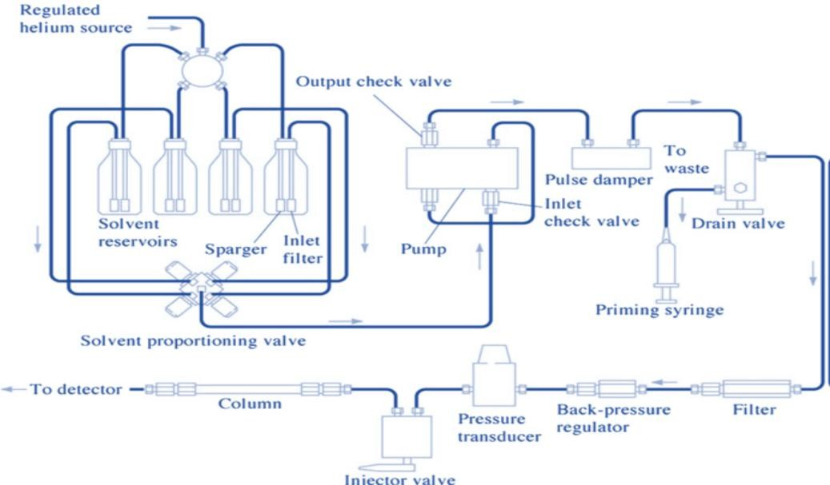
The HPLC system’s schematic representation described in Fig.1.6

Figure 1.1: HPLC system: A schematic representation

HPLC Components
HPLC components are as follows:

Solvent Reservoir
In general, mobile phase employed in HPLC system composed of blend of polar and non-polar solvents to ensure proper separation. Depending on the sample under examine the concentration of different components in mobile ratio varies. Hence the mobile phase sections are kept in separate glass reservoirs to reserve the moveable phase. Inert material such as glass is employed in making reservoirs also it is designed to prevent access of microbes if any.
Pump
Pumps perform the function of aspiring mobile phase into the system from the reservoir. Pumps are used to enforce it through the column while maintaining desired flow rate which is expressed as cc/min. Usually 1-2 cc per min rate of flow is required in HPLC systems. It is possible to deliver mobile phase in both isocratic and gradient mode using pumps. Following characteristics are expected from pump for smooth functioning.
- Constant flow rate
- Non-corrosive
- Capacity to withstand the pressure exerted by the mobile phase flow.
- Compatibility with mobile phase

Types of Pumps
HPLC technique uses two types of pumps, discussed as follows
- Constant pressure pumps: In this pump type continuous flow rate is achieved with gas in cylinder however it got some restrictions like small supply also it permits non-oscillatory flow. E.g, pumps of displacement variety. Constant volume pumps: These pumps permit mobile phase to flow into the column withstanding high pressure. E.g., Syringe pumps, pressure vessel pumps, reciprocating type pumps.

Sample Injector
Introduction of the liquid sample in the instrument is carried out with injector. Sample injecting is a delicate process and precautions must be taken to avoid disturbing column arrangement. Following, direct liquid specimen entry occurs in mobile phase flow stream within column. In HPLC system two types injectors were utilized. The initial method involves a solitary injection, whereas the alternative employs an automated injection system (AIJ). This must be capable to endure pressure built in the system. Usually, 5-20 μL volume of sample may be injected.
Manual Injector
It is an apparatus that contains a measured quantity of liquid sample before injecting it into the system. It has got many components. First it contains a valve, in case of injection of a liquid specimen directly into the eluent flow valve employed the sample's trajectory. After pump head injection is positioned while the introduction of sample is done in load mode. Loading is done by microsyringe maintained under highly controlled conditions. Storage of injected solution is done in
sample loop. The sampling system also employed injection valve for introducing predetermined quantity of sample with unchanged pressure of sample. With rotation of knob to sample flow out of the loop during injection mode and go into the eluent stream.
Auto sampler
Autosampler consists of automated implementation of injection process. This is operated using a micro syringe. This phenomenon works based on computer-controlled programs. However, this process may be performed by the analyst using machines manually. The major advantage of autosampler is injection of large amount of sample.
Pressure Injection Method
This method involves 6-port valve which is attached to sample loop. When a particular quantity of sample delivered from sample enters sample loop, switching of valve takes place so that eluent is carried to the loop followed by subsequent delivery of the sample into the column. In simple words, some procedures executed by analyst with manual injector are accomplished by machines.
Total-Volume Injection Method
This method includes the process of introduction of programmed quantity of sample into a tube from vial followed by eluent directly delivered into the tube. Due to this sample reaches the column. The flow of eluent inside the needle at a different time than that of injection operation is main advantage of the method. Also, with a very minute loss of sample carrying volume greater than conveyed to column is among other benefits of the system. The fluid entering the system must be degassed as it is almost not possible to articulate precise quantity of the sample on the cost of air bubbles from fluids in the track between measuring pump to column needle tip.

Column
Generally heavy glass material or polished stainless steel are among materials employed to make columns as it has to endure high pressure generated during operation. Columns are in the shape of narrow tubes and contain 25μm particles packed within. It is necessary that the internal portion of the column must be smooth and uniform with average internal diameter 4.6 mm. On an average column’s length should be 10-25 cm long. The columns are packed with stationary phase that usually occurs in the form of porous packing of silica usually having particle size in the range of 3–10 μm. While
pellicular packing comprises 30-40 μm diameter of non-porous polymer or glass beads. Microbore columns are the one having internal diameter around less than 2 mm. It is essential to continue the temperature constant of moveable phase and column during the complete procedure. The generally employed columns for HPLC techniques are:
- Analytical columns: In order to execute quantitative analysis these columns are employed commonly they use detectors like UV-VIS.
- Preparative columns: The prime objective of utilising these columns is to collect individual fractions of elements of interest that are exist in combination in specimen.
- Narrow bar columns: This type of column is also employed with UV-VIS, MS or fluorescence detector but are only 1-2 mm in length. In cases where higher sensitivity is expected for the separation these columns are preferred.
- Capillary columns: The length of capillary column is 0.3 mm and fused silica is used in their making while substitute detection systems like MS detectors are essential for their use.
- Guard columns: These columns are used to enhance the lifespan of the column and are short in length. The placing of this type of column is in between injector for samples and column. The protection of the column from particular matter or loss of efficiency or substance adsorbed strongly in mobile phase or sample is prime objective of this type of column.

Detector
The function of detector is of utmost importance as it determines individual element which is moving out from the column which further assists in analyzing quantitatively the component under study which has been separated out of sample mixture. Further detectors make available an output to computer which generates chromatogram followed by interpreting the results. The detectors commonly employed in HPLC are enumerated as such:
- Photodiode array
- UV/Visible
- Fluorescence
- Potentiometric
- Electrochemical
- Refractive index
- Evaporative light scattering detector.
- Amperometry detector.

Computer System
It assists in controlling by and large the module of HPLC, but it also plays a major role in receiving signals from detector followed by interpreting them to estimate retention time of sample. It helps in qualitative analysis of tests and affix quantity of sample required for quantitative analysis.

Factors Affecting on HPLC
Among the factors that severely influence the functioning of HPLC system are thickness of the fixed phase and particle size of beads packed in column, flow rate, internal diameter of the column, viscosity and nature of movable phase, affinity of analyte among both phases, pressure of pump, size of sample, size of injection volume, column packing, sample injections methods and most importantly retention time.

Advantages of HPLC
The most important advantage of HPLC is it is rapid and highly time saving; also it delivers high performance while maintaining extreme sensitivity. HPLC finds its application for qualitative and quantitative determination in analytical as well as preparative domain.

Disadvantages
Certain components get irreversibly adsorbed on the stationary phase as it never elutes and its determination is not possible. Cost is one of the major limiting factors while it is also much more complex and requires maintenance.

Applications
HPLC is one of the useful techniques in analysis and it is employed in separating inorganic ions and plant-based bioactive compounds. It finds application in determining intoxicants, poisons or addictive drugs in human plasma. Even identification of biomolecules like bile acids, steroid hormones, lipids, illicit drugs is possible with HPLC. Among its exclusive appliance investigation in forensic science is significant; it is involved in analysis of nucleic acid research, study of explosives, metabolic profiling as well as pharmaceutical product profiling.
In HPLC, analysis can be done either to recognise the components present in a experiment (qualitative analysis) or to measure the amount of those components (quantitative analysis). Qualitative analysis helps in determining the nature and purity of the sample, while quantitative analysis is performed by comparing peak height of sample with standards. Accurate HPLC analysis mainly depends on obtaining reproducible chromatograms and ensuring that the detector gives a linear response for the analytes being studied.

Qualitative analysis:
To assess an analyte's structural properties and to identify the constituents of unidentified specimens, qualitative analytical techniques are necessary.
1.1 Without Reference Substance
1.2 Reference Substance Available

Quantitative analysis
  - External standard calibration
  - Normalized peak area
  - Standard addition calculation method
  - Internal standard calculation method

Normalized peak area
Once all the important peaks in a chromatogram are integrated, overall area of peak is computed. The percentage contribution of each individual peaks relative to total peak area is termed as normalized peak area.

  - External standard calibration
An external standard is a reference compound identical to the substance detected in specimen being examined. This is the most widely used quantitative analytical approach. This standard should either be highly pure or have a previously established composition obtained through prior analysis. In situations where the primary standard is expensive or available only in limited quantities, a secondary standard may be used as an alternative.
Standard solutions of different concentrations are injected, and calibration graph is structured by graphing peak response against conc. The unknown samples are then analyzed under the same conditions, and their dilutions are established using calibration curve.
The accuracy and precision of analytical measurements may be further improved by preparing the external calibration standard in a matrix that closely matches the composition of the sample.

Using Internal standard Approach:
The technique requires sum of an amount of foreign compound to specimen to be analyzed. The reaction factor of internal standard is either established or fixed. When a sample requires a large number of pre-treatment steps, e.g., extraction or derivatisation, utilization of an internal standard is particularly crucial as this helps to minimise errors that could be introduced during these steps. The internal standard mimics the analyte's behavior during sample treatment so as to enhance the accuracy of the analysis. The various concentrations of the pure drug are plotted against each other to create a calibration curve while keeping the concentration of the internal standard constant. The chromatographic data are then used to determine the response ratio (Rs) for Concentration of the target compound.
Depict this ratio versus pure drug concentration (Rs / concentration of the API).

2.4 Method for Calculating Standard Additions

The standard addition method is based on idea that the analytical reaction is proportionate to level of analyte. In this technique, the initial quantity of analyte contained in the sample is ascertained by measuring signal prior and after supplement of known quantity of the same analyte. This process, commonly referred to as “spiking,” is particularly useful when the sample matrix interferes with the chromatographic behavior of the analyte peaks.

Stages for HPLC approach
- Collecting information about the sample
- Defining the objectives of the separation
- Determining any specific prerequisites or essential sample procedures.
- Choosing and adjusting the appropriate detector
- Enhancing separation conditions
- Checking for possible issues or any additional procedural requirement
- Isolating the refined substance
- Performing quantitative calibration or qualitative analysis
- Validating the developed technique before routine laboratory use

Requirements for Effective Methodology Advancement: Choosing an Appropriate HPLC Column


Choosing right HPLC column constitutes crucial phase in methodologies formulation. Among the available columns, C18 columns are most commonly employed in HPLC examination because of their strong non-polar nature and broad applicability. C8, also known as octyl-bonded columns, are sometimes used as an alternative. Although they are also non-polar, they are less hydrophobic than C18 columns. As a result, hydrophobic compounds usually show shorter retention times on C8 columns. In addition, C8 columns may provide different selectivity due to greater exposure of the silica surface, which can lead to interactions between the bonded phase and electron- deficient functional moeities present in solute molecules. Thr octadecane C18 column’s structure shown below.

Figure 1.2: Chemical Structure of the Octadecylsilane (C18) Bonded Stationary Phase
The retention mechanism in -CN columns is more complex, involving both hydrophobic and dipole interactions. The cyano (C≡N) functional group of the bonded phase can interact with amino groups of solutes, and p–p interactions may also occur with unsaturated compounds. Because of these characteristics, -CN columns are particularly useful for separating polar organic compounds. They are versatile and involved in reversed as well as normal chromatography. The chemical configuration of the -CN column is illustrated in the subsequent figure.



Figure 1.3: – CN Column
Each bonded phase in HPLC provides a different type of selectivity contingent upon the characteristics of the specimen being analyzed. For instance, when separating compounds such as ethyl benzene and toluene, which differ only by a single –CH₂– group, a C18 bonded phase is generally favored. In such cases, a packing material with high carbon loading is selected because it offers stronger retention for hydrophobic compounds and improves separation efficiency. The stationary phase should retain the compounds long enough to allow proper separation through differences in their migration rates. The physical characteristics of both standard and optimized columns are usually considered during method selection. The physical properties HPLC (default and optimum) are given in following Table
Characteristics of standard and ideal columns
Parameter | Column (Conventional) | Optimized Column
Dimensions | 150 × 4.6 mm | 250 × 4.6 mm
Size of Particles | 5 µm | 5 or 3 µm
Surface Area (SA) | 200 m²/g | > 200 m²/g
Pore Size | 100 Å | 100 Å
Carbon Loading | 10% | 16–20%
Base Material | Silica | Silica
Bonding Type | Monomeric | Monomeric or Polymeric
Particle Shape | Spherical | Spherical
Column Dimensions:
This indicates length as well as inner diameter of packed bed in column. The short column format (30 to 50 mm) is beneficial for fast analysis, as it offers reduced run time, quick equilibration, lower back pressure also higher sensitivity. Longer columns (250-300 mm) offer greater resolution and better separation but are more expensive, give higher back pressure, are larger in size and need longer analysis times and more solvent. Another factor that influences chromatographic performance is the inner diameter of the column. Narrow columns (2.1mm or less) minimize diffusion of the sample which leads to sharper, taller peaks with increased sensitivity of detection. But they might need to adjust the chromatographic system so as to prevent peak distortion. Broad columns (10–22 mm) work well with greater amounts of sample.
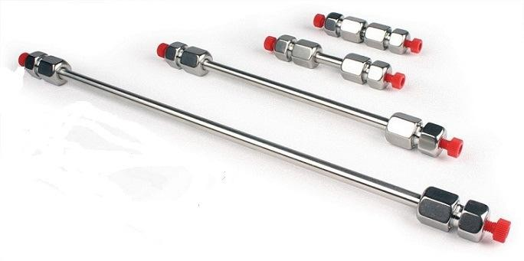

Figure 1.4: Columns with different length
Particle shape:
Most modern chromatographic packing materials are composed of spherical particles, although irregularly shaped particles are also available. Spherical particles are generally preferred because they produce lower back pressure and improve column durability,
especially when viscous mobile phases such as 50:50 methanol-water mixtures are used.
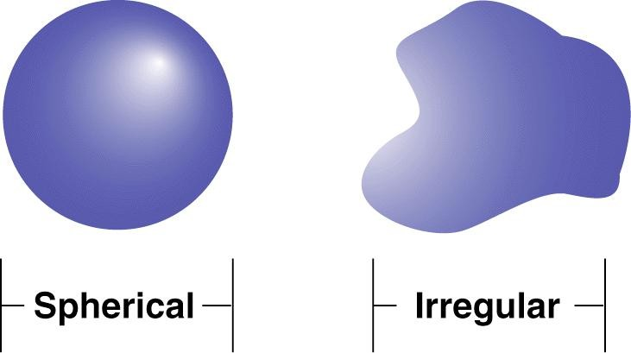

Figure 1.5: Particles with distinct shapes

Particle Size:
The particles size, column's mean packing material diameter. Typical particle sizes are in the range of 3 µm (prominent efficacy separation) to 15-20 µm (preparative applications). Particle size 5 µm is widely accepted as a good compromise for column efficiency while maintaining a reasonable back pressure. Smaller particles pack closer together and cause less sample diffusion and sharper, narrower peaks. They, however, also produce greater solvent pressure. Generally, particle sizes of For separating complex mixtures with multiple components 1.5 or 3 µm are preferred while 5 or 10 µm particles are suitable for routine analysis. Generally, particle sizes of
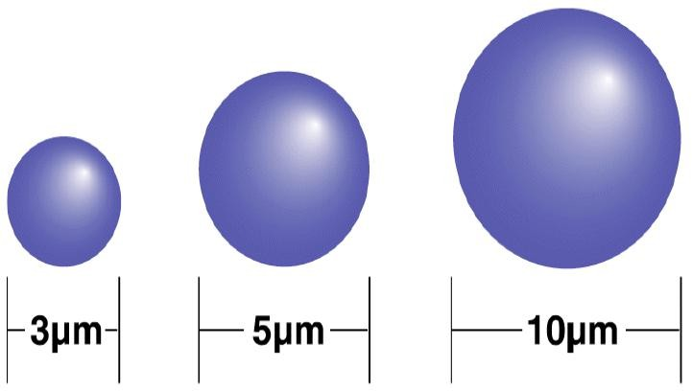

Figure 1.6: Particles with various diameter
Surface area
Surface area, expressed in m²/g, represents total area available on both the outer surface and inside the pores of the packing particles. Columns with higher surface area generally provide stronger solute retention, better sample capacity, and improved resolution. Because of these advantages, packing materials with high surface area are usually preferred for separating complex mixtures containing many components.


Figure 1.7: Distinct surface area particles
Pore size:
The average diameter of openings or cavities within the porous packing material is the “pore size”. The size of pore is in the range of 60 Å to over 10,000 Å. The larger the pores the better they retain larger molecules and the higher the interaction that the analytes will have with the internal surface of the particles. Compounds having molecular weights of 2000 and below are best suited for columns with 150 Å pore size or smaller, and molecular weights greater than 2000 are best suited for columns with 300 Å or larger pore size.


Figure 1.8: Particles with various pore size
Bonding Type:
The bonding method refers to the method used to couple the stationary phase to the basis silica material. The monomeric bonding extends to a specific point on each molecule of the bonded phase, while with polymeric bonding it is attached at more than one point. Typically, polymeric bonding results in higher column stability, especially when mobile phases that are extremely aqueous are employed. Also, it makes column more robust to load of samples.


Figure 1.9: Monomeric and polymeric bonding
Carbon Load:
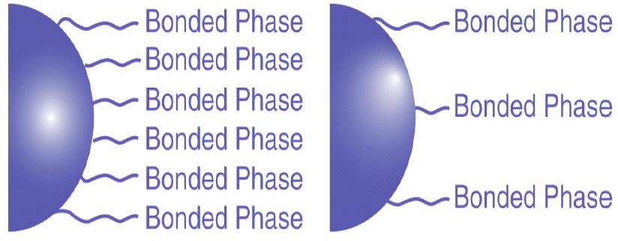
It indicates quantity of bonded stationary phase present on base materials. In columns such as C18, C8, and phenyl phases, carbon load strongly influences hydrophobic retention. Columns with higher carbon load usually provide greater retention, improved resolution, and higher sample capacity, although they may increase analysis time. Lower carbon load, on the other hand, reduces run time and may alter selectivity because more of the silica surface remains exposed. High carbon load columns are generally preferred for complex samples that require maximum separation, while lower carbon load columns are more suitable for simpler mixtures or samples requiring high aqueous content for stability and solubility.

Carbon load

Endcapping:
Endcapping is a process used in reversed-phase chromatography in which small hydrocarbon groups are bonded to the persisting free silanol moieties on the silica surface after the main

bonded phase has been attached. This process helps minimize chromatographic peak tailing resulting from interactions involving polar analytes and exposed acidic silanol groups. Non-
Figure 1.10: Endcapping
endcapped columns may provide different selectivity compared to endcapped columns, particularly when analyzing polar compounds.
The chemical characteristics of the bonded stationary phase play a crucial role in selecting a suitable HPLC column is selected based on sample component’s chemical nature, while physical properties of columns are chosen according to the objectives of the separation technique. The approach helps in identifying the most suitable bonded phase along with particle bed properties required to achieve effective separation.

Detectors

HPLC uses many types of detectors including but not limited to detectors like UV-Vis, PDA, conductivity, fluorescence, electrochemical, refractive index, mass spectrometric also evaporative light scattering detectors. Among these, UV–Vis detectors are most common one as they provide detection for a wide variety of substances.

pH Range
To acquire quality chromatographic analyte peaks separation, pH range of last method needs to be developed between 1 and 12. The separation is primarily based on efficiency, selectivity and retention time of the column. Changes in pH have a significant effect in these parameters since the analytes may be in acid form, basic form or both. Modifying the mobile phase's pH may help to increase the retention time and separate ionized and non-ionized compounds. The ionization of the analytes and residual silanol cohort on silica surface is also affected by changes in pH, which decreases secondary interactions and can therefore lead to poor peak shapes. The mobile phase pH is then systematically changed, typically starting at low pH also elevating to pH higher than desired until a satisfactory partition is achieved.
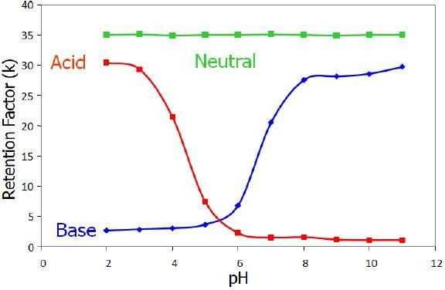

Figure 1.11: Retention factor (Rt) and pH correlation

Composition of Mobile Phase

The mobile phase a significant factor that affects separation. Among most widely utilised solvents in RP-HPLC is acetonitrile (ACN; with a cut-off (UV): 190 nm), methanol (MeOH; cut-off (UV): 205 nm) and tetrahydrofuran (THF; cut-off (UV): 212 nm). All of these solvents are water soluble. Of these, acetonitrile–water mixtures are often used as the starting point in the method development process because they will normally provide an efficient and reliable separation for a widespread range of compounds.

Column Temperature
The temperature of the column is a major influence on the separation of chromatograms. The higher the column temperature, the lower the viscosity of the movable phase, which will lead to a lower system back pressure and allow longer columns to be used for better separation efficiency. But with higher temperatures, some of the sample components may be less resolved. Thus, it is crucial to reflect on analytes character being separated and adjust the optimum temperature accordingly. It is often possible to get better overall separation by varying both column temperature and mobile phase’s composition. These days, normal-phase HPLC is making a comeback, with emergence of HILIC (hydrophilic interaction). This technique provides better reproducibility for the differentiation of hydrophilic also polar and substances including carbohydrates, peptides, polar drugs, vitamins, metabolites. Reliable method development results in better analytical performance and optimal HPLC method development mainly relies on proper optimization of the chromatographic conditions.
  - HPTLC
Pharmaceutical analysis is an essential segment of pharmaceutical development procedure, making availability of simple, rapid quality control techniques very important for commercial formulations. HPTLC is an important separation technique because it allows multiple samples to be examined simultaneously employing only a minor quantity of solvent. HPTLC is based on the same assumption as TLC, where compounds are split according to their different migration rates between two phases on specially designed plates. This technique is widely applied for quantitative and qualitative analyzes, as well as in the detection and assessment of components present in mix.

Steps involved in HPTLC
  - Preparation and activation of HPTLC plates
  - Sample preparation
  - Mobile phase Selection and preparation
  - Sample application on plate
  - Chromatographic development of plate
  - Drying of the developed plate
  - Detection/visualization of spots or bands
  - Densitometric scanning and documentation
  - Data analysis and interpretation
Selection of Suitable Sorbents and Chromatographic Plates for TLC/HPTLC Analysis
Already-coated plates with different support materials are available, in that aluminium support material is common. Usual breadth of 100 - 250 µm is utilised for quantitative, qualitative examination. Generally, analysis 80 % is carried out on silica gel other sorbent used are aluminium oxide, cellulose etc.
The commonly used pre-coated plates and their uses are listed below.

Sr. no. | Plate | Type of Analyte
1 | Silica gel 60 layers | Most of the drugs
2 | Reversed Phase Layers  (RP-2, RP-8, RP-18) | Lipids, Aromatics, Basic Drugs and Acidic analytes
3 | Cellulose and Keiselgurh | Amino acids and sugars
4 | Aluminium Oxide | Basic Drugs

Pre-coated Plates Activation

Activation is typically not necessary for freshly opened HPTLC plates. Nevertheless, if the plates have absorbed moisture due to exposure to humid conditions, they should be activated before use. This activation is commonly carried out by heating plates at 110–120°C in oven for approximately half an hour before sample application.

Preparation of sample

During standard-phase chromatography utilising silica gel or plates coated with alumina, sample solutions are typically prepared using non-polar, volatile solvents. In contrast, reverse-phase chromatography commonly employs to dissolve samples in polar solvents.

Sample Application

For HPTLC analysis, applying samples and standards in the range of 1.0–5.0 µL as bands generally provides superior division, uniform Rf values, also reduced spectral broadening. Utilization of sample is commonly performed using a Linomat applicator, which ensures accurate, uniform, and reproducible spotting.

Pre-conditioning (Chamber Saturation)
Chamber saturation greatly influences chromatographic separation. Saturation is usually unnecessary for low-polarity mobile phases, but it becomes important when extremely polar mobile phases are used. In reverse-phase chromatography, the chamber is generally saturated with methanol or another polar solvent before development.

Mobile Phase Optimization
Suitable mobile phase selection is mainly executed through trial and error. During this process, factors like characteristics of the analyte's chemistry and solvent, analyte solubility, interaction with the adsorbent layer, and practical experience of the analyst are considered.

Chromatographic Development
Various development techniques can be employed in HPTLC, including ascending, descending, horizontal, continuous, gradient, and multidimensional development methods. In most cases, a migration distance of approximately 5–6 cm is sufficient for effective separation on HPTLC plates. Following completion of chromatographic development, the plates are cautiously withdrawn from the developing chamber and dried to eliminate residual “mobile phase” solvents.
Detection of Spots
In HPTLC, spots can be detected by visual observation under UV exposer at 254 nm treating a UV chamber. Detection may also be carried out using iodine vapor in an I₂ chamber.
Once the HPTLC plate development is completed, the plates are scanned at selected ultraviolet wavelengths using a suitable scanner. The separated spots are recorded on the computer as chromatographic peaks. The scanner transforms each band into a peak, with the highest point as well as peak area correspond to the extent of substance appeared in the sample. These values are measured by the instrument and documented quantitatively.

Factors Affecting TLC/HPTLC Separation and Spot Resolution
The quality of separation and spot resolution in TLC/HPTLC is influenced by several factors:
Nature and size (particles) of the stationary or Solid phase | Temperature (T) + humidity during analysis
Mobile Phase Polarity and Solvent Composition | Influence of Plate Activation and Moisture Levels on Chromatographic Performance
Thickness of the adsorbent layer | Solvent purity and quality
Sample concentration and volume applied | mobile phase's pH scale
Method of sample application | Drying conditions after development
Chamber saturation conditions | Detection and visualization technique used
Development distance
HPLC is another extensively utilised chromatographic methodology for the examination of pharmaceutical formulations, biological samples, and bulk medications.
  - Spectrophotometric methods
This technique measures how much light, either UV or visible, a substance in a solution absorbs. The ultraviolet and visible regions of the EM spectrum cooperatively extend over approximately 100–780 nm and are subdivided into distinct spectral regions according to their wavelengths. Quantitative determination using UV–Visible spectrophotometry is primarily governed by the Beer–Lambert law, that establishes a association between the absorbance of radiation and the concentration of an absorbing material. According to this principle, when monochromatic emission routes through a transparent medium containing an absorbing species, its intensity gradually decreases due to absorption. The extent of this reduction depends on the concentration of the absorbing group and the optical “path-length” through which the radiation travels. Under suitable conditions, absorbance is exactly proportional to both the analyte concentration along with length (Width) of the sample cell.
So, law can be expressed mathematically as:
Where, a = absorptivity, A = absorbance, c = concentration of solute in solution, b = length (Width) (cm).
Typically, when doing quantitative analysis of substances in single-component as well as multicomponent samples.
Simultaneous equation approach | Geometric correction approach
Multicomponent analysis method | Orthogonal polynomial technique
Least squares method | Difference spectrophotometric approach
Absorbance ratio technique | Derivative spectrophotometric technique

Derivative Spectrophotometric Method
UV–Visible derivative spectrophotometry is an effective analytical approach for the qualitative documentation and quantitative purpose of chemicals, remarkably when their absorption spectra overlap with those of other analytes or interfering components. With the help of computer- controlled instruments, this method has become highly useful for the simultaneous analysis of multicomponent mixtures using UV–Vise absorption spectrophotometry. In derivative spectrophotometry, standard absorption spectra is mathematically transformed into its first or higher-order derivative forms. This transformation improves the resolution between overlapping bands, minimizes interference from background signals or sample matrices, and produces more distinct spectral characteristics compared to conventional absorbance spectra. As a result, minor spectral details can be detected more effectively.

Area Under Curve (AUC) Approach
AUC method is mainly utilized when sharp absorption peaks are not obtained or when the spectra are broad. In this technique, the integrated absorbance among two chosen wavelengths, λ₁ and λ₂, is measured. The instrument determines area enclosed between spectral curve also horizontal axis over chosen wavelength range. The selected wavelength range is determined after repeated observations to ensure a linear relationship between AUC also analyte conc. Spectra obtained from 0th order and 1st order methods for derivatives are commonly utilised for AUC calculations. After that, concentration data is plotted to create a stand. curve against the corresponding AUC values.

Validation of analytical method
“A process is considered validated when there is substantial evidence that it reliably produces a product that satisfies pre-defined criteria and quality attributes,” as stated by the USFDA.
For analytical testing, method validation is an essential step to confirm the performance of an analysis process for its intended assistance. This process guarantees reliable, consistent and accurate analytical information, required to ensure quality control of pharmaceutical products. It is important especially in regulated situations where there is a requirement for validated methods to prove compliance with the USFDA standards.
Validation of an analytical technique is a series of systematic studies to establish capability of procedure to produce reliable and reproducible results. All regulatory submissions and routine quality control activities with pharmaceuticals, biologicals and medical devices require this validation.
The verification of a statistical procedure typically involves evaluation of several key performance characteristics, including:
- Accuracy – How far the findings are obtained by analytical technique agree with accepted and/or true estimate.
- Precision – “Degree of agreement” between several measurements taken on different samples under identical circumstances.
- Specificity – The capability of the procedure for precise analyte measurement when other impurities, degradation artifacts, or another sample constituents.
- LOD (Limit of Detection) – The smallest concentration that detectable by technique, although it may not be quantified accurately.
- LOQ (Limit of Quantitation) The minimal dilution of analyte that could be correctly and precisely measured quantitatively.
- Linearity – The capacity of an analytical method to provide outcomes that are proportionate to the extent within a certain range.
- Ruggedness – The reproducibility of analytical results below varied normal restrictions, for e.g., changes in analysts, instruments, laboratories, or operating days.
- Robustness – The method's capability to continue reliable and unaffected by modest intended changes in analytical variable during routine use.

Accuracy Definition:

A crucial factor in the validation of analytical methods is accuracy. It describes how closely the value derived from the analytical process agrees with the actual or recognized reference value. To put it another way, it shows how closely the test findings match the real analyte concentration in the given sample. Accuracy also known as "trueness" is essential to guaranteeing that the process can supply accurate and trustworthy results.

Purpose:
The accuracy assessment guaranties that the technique yields accurate and trustworthy findings at a variety of concentrations. It becomes extremely crucial in cases where utilised to determine potency or content of a medicinal compound or pharmaceutical item.

Procedure:
Usually, precision is evaluated by analyzing samples containing precise concentrations of test substance (i.e., standard spiked solutions) at multiple concentration levels often covering the lower, middle, and upper ranges of the method’s working range (e.g., 80, 100, 120% of the nominal conc.). The findings obtained are then compared with the theoretical (true) values.

Acceptance Criteria:
To meet regulatory expectations and ensure reliability of the method, the following criteria for approval are generally applied:
- The percent recovery of drug at each concentration level should go down within the range from 98 to 102%.
- The RSD (Relative Standard Deviation) at any given level shouldn't exceed 2.0%, indicating good precision in the measurement of accuracy.
- The overall average percent recovery (calculated from all levels) should also lie between 98.0% and 102.0%, with the overall % RSD not exceeding 2.0%.
The precision of an methodical process provides a strong indication of its means to yield results that truly reflect actual content of the analyte in sample. Meeting the defined acceptance criteria ensures that the method is not only valid but also dependable for its intended use in QC and regulatory compliance.

Precision Definition:
Precision refers to level of consensus or closeness among several independent measurements taken from the same uniform sample under defined circumstances. It grants an indication of the repeatability or consistency of the analytical technique. Precision is essential among several independent measurements taken from the same uniform sample under defined circumstances.
Meticulity is typically evaluated at three different levels:

Repeatability (System Precision):
How well one analyst's measurements match up with another's within a relatively short time frame and under identical operating conditions utilising the same equipment.

Intermediate Precision (Ruggedness):
The variability within laboratories, determined by analyzing the same sample under different conditions for example, various analysts, tools, and days.

Reproducibility:
Comparing the results of different labs (inter-laboratory studies), typically applicable in collaborative studies and not always required in routine validation unless specified.

Purpose:
Evaluating precision is crucial for ensuring that the analytical method delivers consistent results within an acceptable range, regardless of small changes in test conditions. It confirms the method’s reliability in routine use.

Acceptance Criteria:
To comply with regulatory guidelines and ensure method suitability, the following acceptance criteria are applied:

System Precision:
  - Evaluated by multiple injections (usually six) of a standard solution.
  - The percentage of variation in the peak area's relative SD of each analyte should be not more than 2.0%, or as specifically defined under the analytical method's system suitability criteria.

Method Precision (Repeatability):
  - Assessed by preparing and analyzing six independent sample solutions under the same conditions.
  - The % RSD of the six assay findings should be not more than 2.0%, demonstrating consistent performance of the method during normal operation.

Intermediate Precision (Ruggedness):
  - Conducted by analyzing six samples under varied conditions (e.g., different analysts, instruments, or days).
  - The total RSD of all six tests must be <2.0%.
  - Additionally, when outcomes of the method's accuracy and intermediate precision are pooled, the overall % RSD should also be not more less than 2.0%, showing that the approach is reliable across varied operational conditions.
Precision assessment confirms the repeatability and consistency of an analytical method, ensuring that it can produce reliable results during routine analysis. Meeting the defined precision criteria is essential for controlling compliance and QA in pharmaceutical analysis.

Specificity Definition:
Specificity is defined as capability of an analytical technique to unequivocally determine whether the analyte is present when potentially present with certain components in sample matrix. These components may include impurities, degradants, excipients, or other potential interfering substances.
Specificity plays a vital role in:
- Identification tests: In order to guaranty that the analytical approach correctly identifies analyte.
- Purity tests: To confirm all potential impurities, like connected compounds, toxic metals, or lingering solvents, are accurately detected and quantified without interference.
- Assay tests: To guarantee this approach yields an accurate and reliable measurement of the analyte’s potency in the sample, unaffected by the presence of other components.
The method's capacity to differentiate analyte from other substances is fundamental to ensure its suitability for its intended use, particularly in complex formulations or stability-indicating methods.

Purpose:
Specificity ensures that the analytical approaches is capable of providing accurate and reliable results by effectively isolating and quantifying the analyte without interference from other substances. This is especially important for evaluating the purity and potency of pharmaceutical substances and products.

Acceptance Criteria:
To warrant that the analytical method meets the required level of specificity, the following acceptance criteria are applied:

Blank and Placebo Interference:
  - When blank and placebo solutions are analyzed, no peaks should elute or interfere at peak of analyte's retention time.
  - This confirms that excipients, solvents, or other formulation components do not contribute to the analyte signal.

Comparison with Spiked Samples:
  - Triplicate samples spiked with known impurities studied in detail and compared with findings of method precision study.

What differentiates the mean result of spiked samples and average outcome from method precision should be not > 2.0%.
  - This ensures that the approach can distinguish between the analyte and impurities without compromising the accuracy.

Peak Purity Assessment:
  - The analyte peak(s)' peak purity in spiked samples should be verified using a diode array detector or equivalent system.
  - The analyte peak must pass the purity criteria, confirming that it is not co- eluting with other compounds and is spectrally homogeneous.
Specificity is an essential characteristic of a validated analytical method, particularly for assays and impurity testing. A method that meets specificity requirements ensures the accurate identification, quantification, and purity assessment of the analyte, which is critical for control of quality and conformity with regulations in the pharmaceutical analysis.

Sensitivity [LOD and LOQ]
Definition:
The LOD is defined as threshold at which analyte concentrations in samples are detectable by the analytical method, although the precise amount may be difficult to ascertain. It represents point at which presence of analyte reliably differentiates from background noise, though precise numerical measurement is not feasible.
The LOD, conversely, it is the smallest amount of test compound that can be reliably and precisely determined through quantitative methods. It marks lowest concentration that allows the analyte to not only be detected but also reliably measured.

Purpose:
LOD and LOQ are important parameters in method validation, especially for impurity profiling, trace analysis, and stability-indicating practices. These limits determine the sensitivity of the method and ensure that even small amounts of analyte or impurity can be accurately identified and quantified, where applicable.

Calculation:
LOQ and LOD are typically determined by utilising signal-to-noise methodology or constructed on response's SD and the Standard curve's slope, as recommended by ICH guidelines.
In this method, following equations are applied:
Where:
- N = SD of response (e.g., peak area of the analyte)
- B = Calibration curve slope (derived from linearity studies)
These calculations help to explain the smallest amount of analyte can be minimum detected (LOD) and quantified (LOQ) by technique under validation.
Determining the LOD and/or LOQ is fundamental for evaluating the sensitivity and performance of an analytical method. Ensuring that these parameters are established and meet expected criteria supports the method’s competence to detect and quantify low levels of analyte or impurities, contributing to overall method reliability and regulatory compliance.

Linearity Definition:
The capacity of an analytical method to provide results that are precisely proportional to the analyte concentration within a certain range is known as linearity. It confirms that the analytical response (e.g., peak area or absorbance) increases or decreases in a linear fashion with increasing or decreasing analyte concentration.
Linearity is fundamental to ensuring that the method can accurately and consistently quantify the analyte across the range of concentrations expected in routine analysis.

Purpose:
The purpose of evaluating linearity is to demonstrate that the analytical method provides conclusions that are both accurate and reliable across the working range. It is especially critical for assays, content uniformity testing, and quantitative impurity analysis.

Procedure:
Linearity is assessed by preparing and analyzing a minimum of 5 different conc. of the analyte, predictably spanning from 80% to 120% (or broader, as required) of the target concentration. The analytical response is plotted against conc. to generate a standard curve.
The relationship is evaluated using regression analysis, where key statistical parameters such as have r-value, slope, and y-intercept determined.

Acceptance Criteria:
- The calibration curve's correlation coefficient (r), which shows a strong linear connection between the analyte concentration and the response, should be at least 0.999.
- Additionally, residuals (discrepancy between the projected and actual values) should be minimal, and the curve should not show significant curvature or deviation from linearity.
Linearity assessment ensures that the analytical technique can reliably measure the analyte conc. within the specified range. This method's accuracy is validated by a correlation coefficient of ≥0.999 suitability for quantitative analysis and supports its application in routine QC and regulatory submissions.

Ruggedness Definition:
Ruggedness refers to level of consistency in test outcomes when utilizing the same specimen is analyzed under varied operating conditions. These variations can include different analysts, different labs, dissimilar instruments, diverse reagent lots, and uncommon days. Ruggedness is also often referred to as intermediate precision and reflects method's durability and dependability in standard operating conditions.
This parameter is essential to exhibit that the analytical method performs consistently across different operational environments, rendering it appropriate for regular practice use in quality control settings.

Purpose:
Evaluation of ruggedness ensures that minor and deliberate variations in testing requirements do not significantly impact the test outcomes. It highlights the method’s reliability and verifies its suitability with extensive and consistent application in different laboratories and by different users.

Procedure:
Ruggedness is typically assessed by analyzing the same sample manifold times (commonly six replicates) under varying conditions such as:
- Various instruments
- Different analysts
- Discrete lots of reagents or columns
- Separate days
The results are then compared to assess the variability introduced by these factors.

Criteria of Acceptance:
- The overall % RSD of assay conclusions obtained under varied conditions should be not more than 2.0%.
- This specifies that the method maintains precision and consistency even when slight variations in operating conditions are introduced.
Ruggedness is a vital module of method validation that demonstrates the reproducibility and reliability of the analytical procedure under realistic, variable laboratory conditions. Meeting the ruggedness criteria ensures that the technique is dependable for routine analysis across different users, instruments, and environments, thereby supporting regulatory compliance and product quality assurance.

Robustness Definition:
Robustness is termed as the capability of a procedure to maintain accuracy regardless of purposeful tweaks to the method's parameters. It gives a measure of the method’s dependability and consistency under normal, routine usage conditions.
Evaluating strength helps to identify factors that may influence method performance and ensures the method’s suitability for use over time.

Purpose:
The purpose of robustness testing is to establish that the method is stable and reliable, even when minor adjustments or variations are introduced. This is crucial in ensuring consistent analytical performance during routine operations, manufacturing scale-up, and across different laboratories.

Procedure:
Robustness is typically assessed by implementing modest, controlled relies on technique parameters like:
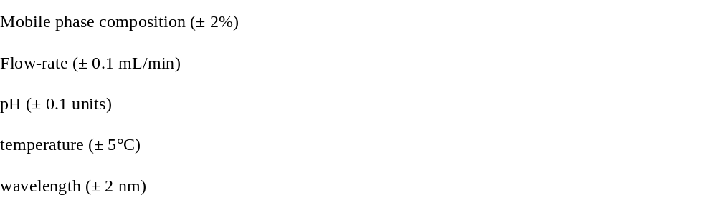The impact of these changes is evaluated by analyzing the same sample under each condition and comparing the results.

Acceptance Criteria:
- The overall % RSD of the results obtained under these varied conditions should be not more than 2.0%.
- This confirms that the method retains its precision and accuracy despite small fluctuations in testing parameters.
Robustness testing is a key component of technique validation that confirms the stability and dependability of an analytical method. By ensuring that small, deliberate adjustments in analytical parameters do not substantially affect the outcome, robustness testing validates the method’s capability for consistent performance under routine laboratory conditions.

SST

Definition:
System Suitability Testing (SST), a critical component of chromatographic reasoning validation, particularly for GC and HPLC techniques. It is conducted to make sure that the chromatographic system performs consistently and meets the necessary quality standards prior to or during the analysis of samples.
SST provides assurance that analytical system is functioning properly also capable of producing outcomes with the required accuracy, precision, and resolution. It is typically performed using a standard solution prior to sample analysis.

Key Parameters for System Suitability Testing
Each SST parameter provides insights into specific aspects of system performance. The following metrics are commonly evaluated:

Capacity factor (K')
K' = ( tR– to) /to
Where, tO = is the dead time for column tR= is the band time for retention
K' represents its retention behavior in a column, and the capacity factors quantify the location of the peak of gained in kith and kin to the void, i.e., the time it takes for the leftovers to elute. Compounds with small values of k' are poorly maintained and elute close to empty volume. Good separation is indicated by a large value of k', however the analysis time is greater, peak widening occurs, and sensitivity decreases.
Suggestion: In most cases, k' > 2.0, and the peak should be clearly visible apart from any different peaks or void volume.
Tailing factor (T)
T: Maximum height minus the distance from the baseline to the peak's heading edge It is a maximum symmetry metric that starts at 1 for peaks with perfect symmetry and goes up as the tailing gets worse. Increased tailing of a peak leads to lower accuracy of quantitation.

Recommendation: T must be ≤ 2

Theoretical plates (N)
N theoretical plates make up a chromatographic column. Within each plate, analytes undergo a thermodynamic equilibrium as they move from the mobile to the stationary phase. The capacity of an analytical method to provide conclusions that are precisely proportional to the analyte concentration within a certain range is known as linearity. The following formula is used to empirically calculate N from a chromatogram:
Recommendation: N should be > 2000.

Precision
Injection precision, stated as relative SD, reflects the overall implementation of the chromatographic system, including the plumbing, column efficiency, and ecological environment during sample analysis. Note that production changes and sample preparation are not taken into account.
Recommendation: For n = 5, an RSD of 1% is optimal.

Resolution (Rs)
Here, W₁, W2 are the baseline bandwidths, while t1 and t2 are the retention durations.
Resolution provides a quantifiable evaluation of the column's ability to separate two analytes. Retention period (Rt) as well as width of peak, that are readily obtainable from the chromatogram, are used to calculate this value. The resolution must be at least 0.5 in order for two peaks to be identified as distinct. If R is larger than 2, two peaks are regarded as entirely distinct. Lengthening the column is one technique to improve the resolution, but it will take more time to analyze.
Recommendation: The distance between the A-point and the nearest eluting possible interference is higher than two.

CHAPTER -2
DRUG PROFILE

DRUG PROFILE:

Lenalidomide Structure:
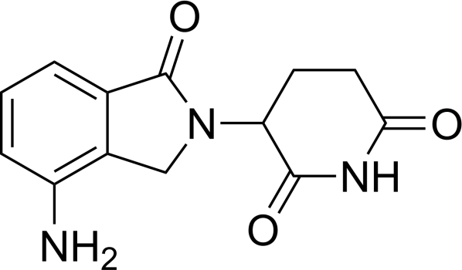

Formula | : C13H13N3O3
Molecular Mass | : 259.26
Description | : light yellow to whitish-white
Solubility | : Able to dissolve in water, buffered aqueous solvents, and organic solvent/water mixtures. It dissolves better in solutions with a low pH and organic solvents.
MM | : 268-270 ℃
Dosage | : 10 mg
Category | : Immunomodulatory imide drugs (IMiDs)
pKa | : 4.7
Mechanism of Action | : - Immunomodulation (↑ T-cell & NK activity)  - Anti-angiogenesis

- Direct anti-tumor effect
- Cereblon-mediated protein degradation
Pharmacokinetics | : Absorption: Rapid (Tmax 0.6–1.5 h) Bioavailability: High  Distribution: 30% protein bound  T_{1/2}: ~3–5 h
Dosage & Administration | : Typically, 25 mg OD (varies by indication); dose adjusted in renal  impairment
Adverse Effects | : - Neutropenia, thrombocytopenia  - Fatigue, diarrhea  - Rash, pruritus  - DVT, hepatotoxicity  - Teratogenicity
Contraindications | - Pregnancy (Category X)  - Hypersensitivity to lenalidomide
Black Box Warnings | : - Severe birth defects (strict pregnancy prevention required)  - Blood disorders  - Thromboembolism risk
Drug Interactions | Limited due to minimal CYP involvement; caution  with myelosuppressive agents or thrombotic risk enhancers
Storage Conditions | : 25°C (77°F); store in  original packaging

CHAPTER -3
REVIEW OF LITERATURE

- Review of Literature
According to the literature review, there are not many reported analytical procedures for determining Lenalidomide in bulk, biological fluid, and medication formulation. The detailed account of these methods is as follows
Analytical Method for Determination of Lenalidomide

Methods for the detection of genotoxic impurities, related substances, and lenalidomide using a tandem UHPLC-UV-MS system that indicates stability [44]
The immunomodulatory agent lenalidomide is a powerful immunomodulatory agent that is used in the treatment of MDS. To get an understanding of the stability and stress-related degradation behavior using a new tandem method that combines UHPLC with UV light and mass spectrometry, boasting exceptional specificity, accuracy, precision, and robustness was designed and validated. Lenalidomide was profiled and quantified for its impurities by UPLC, an ACQUITY UPLC Phenyl column, affirmed at 30 °C, while the sample compartment temperature was regulated at 15 °C. The injection volume was fixed at 1.0 µL, and chromatographic detection was carried out at a λ of 254 nm. A mixture of 0.1% HCOOH and ACN in a 90:10 (v/v) ratio was employed as the diluent. The mobile phase consisted of 0.1% HCCOH as A solvent and ACN as B solvent. For impurity profiling, gradient elution was completed over 20 minutes at a rate of flow of 0.2 cc/min. In contrast, quantitative assay determination was accomplished using a 7-minute gradient programme with a rate of flow of 0.3 cc/min. This method is good linear for all analytes and they can be quantified accurately. Research on lenalidomide's stability under stress and light revealed that it was stable when exposed to hot conditions (105 °C for 11 days) and to daylight/UV conditions, but showed a high degree of degradation when exposed to hydrolytic and oxidative circumstances. The major dreadful conditions products A, B and E were obtained under hydrolysis conditions, and the impurities C (conversion of –NH₂ to –NO₂) and I (conversion of –NH₂ to – NH–OH) were obtained under oxidative stress conditions. Methanol, which is frequently employed in the synthesis of lenalidomide as well as analytical work, was identified as a key reaction component in the formation of impurities. The compounds designated J and K, formed through cleavage of the glutarimide ring, were proposed to be constitutional isomers, with their structural identities subsequently verified using UHPLC–Q-TOF-MS and NMR spectroscopic techniques. It was also successfully used to monitor the impurity G that was identified as a potentially genotoxic impurity (PGI) by the ICH M7 guidance, thus allowing the impurity to be kept under Toxicological Threshold Concern (TTC = 1.5µg/day, 60ppm) with regard to patient safety, as required by the health authority. This comprehensive analytical study renders time-dependent stability and safety of lenalidomide assured and provides hints towards degradation pathways. The results help to develop better impurity control strategies, optimize manufacturing processes and meet regulatory requirements for the entire class of drug substances that contain glutarimides like pomalidomide and thalidomide.

Lenalidomide Dosage and Bulk Estimation through UV Spectrophotometric and RP-HPLC Techniques [45]
The ongoing research have established simple, economical, precise, quick isocratic RP-HPLC along with UV methods for assessment of bulk Lenalidomide drug and pharmaceutical formulation. The analysis was done at 250 nm that computed to be λmax by UV spectrophotometer. RP-HPLC analysis was performed using a Waters C18 RP column. The chromatographic mobile phase comprised 20 mM acetate buffer, adjusted to pH 5.0, and CH₃OH in a volumetric proportion of 85:15 (v/v). The solvent mixture was delivered over the column at a unbroken flow rate of 1.0 cc/min, while the detection wavelength was maintained at 250 nm throughout the analysis. The developed procedures were successfully validated following ICH Q2 (R1) regulations. The developed UV& RP-HPLC spectrophotometric techniques showed an excellent linearity with correlation coefficient (r²) 0.998 and 0.9986 are the values. SD as a percentage for both the approaches was found to be < 2%. This suggests that both the methods are highly precise. The average % recovery was calculated to be about 99.2% and 99.6% for the UV and RP-HPLC technique respectively. The results showed that both approaches were reliable, selective, and specific for routine analysis of Lenalidomide capsule based on the data obtained.
Examination of Lenalidomide's Chemical Stability in CH₃OH/C₂H₅OH Solvents By means of LC-MS and RP-HPLC-UV [46]
A heterocyclic medication called lenalidomide is used to treat myelodysplastic syndrome. The present study focuses on the structural clarification of novel degradants that arise spontaneously when lenalidomide is stored in methanol, and then suggests a mechanism for their creation. Two tetrahedral mediates are produced by the nucleophilic addition of CH₃OH to the carbon of the =C=O consortium of the imide ring in the suggested structures of the degradants, which are comparatively stable. As a solvent, methanol molecules may help stabilize the intermediate by forming hydrogen bonds with it. It was discovered that the lenalidomide/methanol solution included a large number of these degradants. Therefore, it is essential to evaluate them toxicologically.

Investigation of Lenalidomide–DNA Interactions In Vitro Through Spectroscopic Analysis and Molecular Docking Studies [47]
The binding behaviour of lenalidomide (LEN) toward calf thymus DNA (ct-DNA) was extensively explored under simulated physiological circumstances (pH 7.4) through an integrated approach involving UV–Visible absorption, and molecular docking simulations. Spectroscopic observations revealed a strong association between LEN and ct-DNA, with an estimated binding constant (Ka) of 2.308 × 10⁵ M⁻¹ at 283 K. Minor reductions in absorption intensity, together with changes observed in the CD spectra, supported the involvement of a groove-binding mechanism. Thermodynamic evaluation at three temperatures indicated -ve Gibbs free energy (ΔG < 0), +ve enthalpy (ΔH > 0), and negative entropy (ΔS < 0), demonstrating the spontaneous nature of complex formation and suggesting contributions from hydrogen bonding and hydrophobic interactions. Competitive displacement assays employing ethidium bromide and 4′,6-diamidino-2-phenylindole (DAPI) provided additional evidence that LEN predominantly occupies the minor groove of double-stranded DNA. Fluorescence measurements established an average excited-state lifetime of 7.645 ns and a quantum yield (φ) of 0.09, while also indicating the occurrence of nonradiative energy transfer between DNA and LEN. The molecular docking findings further supported the binding characteristics identified through experimental investigations. Overall, the study provided insights into the molecular distinguishing of LEN by DNA and demonstrated the usefulness of complementary spectroscopic and computational techniques for characterizing drug–biomolecule interactions. These findings may also contribute to future investigations of LEN's biological interactions and its potential use in combination with other therapeutic agents.

Successful Management of Lenalidomide-Associated Psoriasis Using Narrowband Ultraviolet B Phototherapy in a Patient with Refractory Multiple Myeloma [48]
This article discusses a case study of a sick person with refractory multiple myeloma that developed psoriasis as a side effect of lenalidomide treatment. The patient was effectively treated with narrowband UV B phototherapy (NB-UVB) without discontinuing the lenalidomide. The article highlights the efficacy and protection of NB- UVB in managing lenalidomide-induced psoriasis and suggests that NB-UVB can be contemplated as a therapeutic option for psoriasis secondary to anti-multiple myeloma agents. However, further validation through larger prospective trials is needed.

Lenalidomide Capsules and Related Substances: A New, Fast, and Accurate HPLC Assay Method [49]
A chromatographic technique was developed to identify lenalidomide and associated compounds in 10 mg and 5 mg pills by employing a SunFire C18 HPLC column (250 × 4.6 mm) using a mobile phase comprising of solvents A and B in an 8.5:1.5 proportion. Mobile phase A comprised a blend of phosphoric acid buffer and sodium 1-octanesulfonate, whereas mobile phase B contained CH₃OH and ACN combined in a volumetric ratio of 55:45 (v/v), respectively, at a 40°C and a wave length of 210 nm. H₂O, 1/10 N HCl, 1/10 N NaOH, 1% volume/volume H₂O₂, humidity, and 254 nm UV light sunlight, and heating at 60°C were used in the degradation investigations. Although there was some minor deterioration in alkaline conditions with NaOH, lenalidomide did not exhibit significant degradation in the majority of stress conditions. The method's suitability for steadiness investigations was sanctioned by the developed HPLC method, which showed peak purity angles below the threshold values. For metrics including accuracy, linearity, precision, ruggedness, resilience, methodology was satisfactorily validated.
Lenalidomide HPLC Assay Method Development [50]
The Inertsil ODS-3 V column was used to achieve the chromatographic parting of lenalidomide and its impurities. The liq. phase was a combination of 80:8:12 v/v of buffer, acetonitrile, and methanol. At 60 °C, with the help of HCl (1/2 N), NaOH (1/2 N), H₂O₂ (10% v/v), and UV radiation (254 nm), additional stability experiments on degrading bulk lenalidomide samples were conducted [20source]. Only under typical hydrolysis conditions was significant deterioration observed. A mass balance value of almost 99.5% was obtained using the established LC method, demonstrating the suitability of the produced stability indicating LC method. Linearity, precision, accuracy of technique was validated as well.
Stability-Indicating Method for Lenalidomide [51]
Establishing an efficient, sensitive, affordable, and straightforward RPHPLC for identifying and measuring Lenalidomide (Lena) contaminants in Lena solid dosage’s is the main aim of the study. In order to provide a straightforward, quick, delicate, precise, and reliable gradient HPLC technique for evaluating and quantifying Lenalidomide and its impurities, the present study inquiry was driven by the dearth of research effort and the absence of compendial methodologies accessible for estimating this medication. Samples are examined using reverse phase (RP-HPLC). The specificity of the HPLC technique was verified by chromatogramming the solutions of lenalidomide and related chemicals in the blank and spiked sample. Specificity tests show the peaks are distinct. The results met accuracy standards. Impurity-A has a detection limit (LOD) of 0.1124 µg/mL and a quantitation limit (LOQ) of 0.0371 µg/mL, while Impurity-B has both at 0.2247 and 0.0742 µg/mL. Lenalidomide and each impurity within the concentration range have linearity correlation coefficients above 0.99. The precision of the analytical method was judged at the designated concentration levels, and the corresponding percentage recovery values for lenalidomide and its associated impurities were found to be within the established acceptance limits. Stability investigations demonstrated that the standard, sample, and impurity-spiked mixtures remained stable for up to 48 h under both benchtop and refrigerated storage conditions. Furthermore, filter compatibility studies confirmed that spiked sample solutions could be effectively processed through 0.45 µm polyvinylidene fluoride (PVDF) and nylon membrane filters without adversely affecting analytical performance. These findings supported the suitability of the evaluated conditions within the established method validation parameters.

Designing and validating RP-HPLC methods for lenalidomide degradation studies [52]

A simple and accurate RP-HPLC approach was devised to calculate lenalidomide. The analysis was operated utilizing ShimadzuLC-2010 HT RP-HPLC instrument. Separation was gotten using shim-pack C18 column maintained at 25 ºC and a mixture of phosphate buffer and ACN (5.5:4.5). With a flow rate having 1 CC/min and UV-visible detector was set at 242 nm. Lenalidomide exhibited a chromatographic retention time of 2.5 minutes. Over the conc. range of 25-150 μg/mL, the calibration curve exhibited linearity with regression equation Y=5223x+183075. Recovery studies verified the method's accuracy. The retention time developed was shorter than previously reported methods. Thus, the validation results confirmed simplicity, rapidity, precision and accuracy of RP-HPLC making it suitable for daily examination of lenalidomide from bulk drug substances and dosages.

Novel Spectrophotometric Approaches to the Quantification of Lenalidomide in Medicines [53]
Two simple spectrophotometric approaches, designated as Approach A and Approach B, were elaborated for the quantitative determination of Lena in pharmaceutical dosage forms. Method A involved a diazo-couplings with N-(1-naphthyl) ethylenediamine dihydrochloride (Reagent Used: B.M.), resulting in the formation of a stable purple-coloured compound exhibiting maximum absorbance at 540 nm. In contrast, Method B relied on a condensation reaction between lenalidomide and the aromatic aldehyde p-dimethylaminocinnamaldehyde (PDAC), producing a coloured reaction product with an absorption maximum at 530 nm. Both methods employed the measurement of absorbance at their respective wavelengths for the spectrophotometric estimation of lenalidomide in pharmaceutical preparations. In the conc. range of 1 to 5 µg/cc both of the suggested procedures (Method A and Method B) followed Beer's law. The techniques were approved for routine Lenalidomide QC of formulations.

Creation of a RPHPLC technique for the recognition of lenalidomide-related contaminants [54]
A RPLC method was advanced for the separation, identification, and determination of lenalidomide (LENA) and its associated impurities. Forced degradation experiments were supervised under numerous stress conditions, with thermal exposure, acidic and basic hydrolysis, and oxidative treatment, to investigate the stability characteristics of lenalidomide. Among the evaluated conditions, alkaline treatment produced substantial degradation, indicating the compound's pronounced susceptibility to basic environments.
The study results showed good peak resolution for fresh sample, acidic stress and thermal stress conditions. In case of thermal degradation, the resolution values between adjacent peaks were found to be 3.6, 3.2, 5.3 and 4.7 respectively. This shows that the developed method gives satisfactory separation and resolution of the degradation products formed during thermal stress conditions.

Development, Validation, and Green Analytical Assessment of a Quantitative Method for Lenalidomide (LENA [55]
Lenalidomide is described as having immunomodulatory, anti-inflammatory, anti-angiogenic properties. In order to measure lenalidomide in pure materials and pharmaceutical formulations, this research developed and verified environmentally friendly HPLC and spectrophotometric techniques. The HPLC mobile phase consisted of a 5:5 volume ratio of ethanol and 10 mM K H₂ phosphate solution (pH: 2.0). Using a 304 nm UV detector, elution was carried out isocratically at 1.0 cc/min. Standard solution spectral patterns in different solvents were investigated using the spectrophotometric approach. 304 nm as the measuring wavelength and ultrapure water as the solvent produced the best spectra. These techniques were verified across many criteria in accordance with ICH recommendations. For both techniques, correlation coefficients more than 0.999 were discovered at doses between 5 and 30 μg mL−1. The techniques were used on commercial preparations, and the Fisher F-test for standard deviations and the student’s t-test for averages were used for analysis. There was no discernible difference between the methods. AGREE software was used to evaluate the sustainability of the procedures. The developed methods for quantifying Lenalidomide in pharmaceutical formulations are remarkable and user-friendly, with environmental considerations.

A RPHPLC method was managed to simultaneously determine thirteen related substances in LENA API. [56]
Researching potential HPLC approaches for separation also purpose of related impurities in lenalidomideAPI. Utilizing pH 4.0 phosphate buffer-ACN gradient as a mobile phase for chromatographic separation, the analysis of lenalidomide was performed. The separation was succeeded on a Zorbax SB-AQ column with a 220 nm wavelength. The results of method validation made understood that the described approach is specific, linear, and repeatable.
The LOD ranged from 2-17ng/mL while the limit of LOQ ranged from 6-50ng/mL. For the calibration procedure, a direct linear regression of lenalidomide and impurities peak area (mg/ ml) was applied using eight concentrations. The regression coefficient was found to be r≥0.999. The oxidation and base degradation products of lenalidomide were identified with the confirmation of their chemical structures. A single analytical procedure was developed for the qualitative and quantitative analysis of 13 related substances in Lena API. Assays and quality control procedures in standard laboratory testing can make use of method.

Accurate and Reliable HPLC Approach for the Separation of Enantiomers of Len from Bulk and formulations [57]
A rapid, stability-indicating and simple chiral development HPLC technique for the separation of the enantiomers of lenalidomide (LDM) in existence of degradation products. Drug subjected to significant pressure conditions in order to study its availability and separation of the degradation products and pure drug was precisely analyzed for enantiomers. The separation completed on a cellulose-2 chiral column using methanol and glacial acetic acid, the LUX 5U series, and triethylamine at a 1.2 mL/min as the liquid phase. The internal standard was Ornidazole and the exposure was accomplished at 220 nm. The presented method was assessed for specific analytical genres. Stability, limit of detection, quantification, specificity, precision, linearity and accuracy, and resilience in the solution parameters were assessed. The calibration curve exhibited good linearity (2–1000 ng/mL range) for each of the enantiomers with correlation coefficient 0.9999 Validation of the protocoal was achieved according to ICH as well as FDA requirements and was successfully utilized in the investigation of Lena in both bulk API and capsule formulations. The assay results indicated they were quite accurate for detecting the presence of protein and precision, with label claim values of 100.09 ± 0.80% for both the S-(−) enantiomer and OR: 99.97 for R-(+) enantiomer + x-0±0·93% These results mean that method is less RPTLC is reliable well-suited for regular stability and quality control investigations of lenalidomide.

Characterization of Lenalidomide Degradation Behaviour Using HPLC and LC–MS Analytical Techniques [58]
The potential for toxicity makes lenalidomide a very potent and potentially fatal drug for human birth defects. Such medications necessitate extreme caution when handled. The lenalidomide drug-excipient mixture, which was extracted from the capsule, was subjected to a number of stress tests recommended by ICH guidelines e.g. thermal stress, hydrolysis under different pH conditions, oxidation and in the presence of light. The medication was stable in thermal and light but sensitive to other stressors. We tracked the degradation of drug solutions with different products at different period intervals applying different stressing agent concentrations to develop a stability method. Adjusting LC parameters optimized chromatography. The separation was successful using a multi-step descent elution technique on an ACE® C18 stainless steel analytical column. Mobile phase A (pH 2.0 ± 0.1 phosphate buffer,) and moveable phase B (200:800 (v/v) water-acetonitrile mixture) were used for chromatographic analysis. Detection occurred at 220 nm, with moveable phase brought at 1.0 cc/min. The significant degradation products had RRTs of 0.75, 0.86, 0.96, 1.33, 1.52, 1.99, 2.04, 2.62, and 2.66, in order.
Lenalidomide in Pharmaceutical Preparation: Capillary Electrophoretic Method Coupled with Photodiode Array Detection [59]
A capillary electrophoresis way was established for the quantitative analysis of lenalidomide (LEN), employing metoclopramide as the internal standard (IS). Separation was accomplished using a deactivated fused-silica capillary at 22 °C, with 20 mM phosphate buffer (pH 7.1) and CH₃OH (9:1) as the background electrolyte. The method effectively distinguished LEN from its stress-induced degradation products. Excellent precision (RSD ≤ 0.59%) and satisfactory recovery (98.53–100.80%) were observed. Application to bulk drug and capsule formulations yielded an assay value of 99.52 ± 0.43% of the labelled amount, demonstrating the eveloped method for routine quality control analysis and stability evaluation.
Constructing and evaluating an RP-HPLC Method to Denote Stability [60]
A sensitive RP-HPLC technique was made to determine Lenalidomide in capsules. The samples are analyzed by RPHPLC. Analyzes were conducted utilizing a C18 column (5μm), pH 2.5 phosphate buffer, ACN (9:1), rate 1.0 cc/min, temp. 30°C, sample cooler temp 5°C, wavelength 210 nm and injection volume 10 μL.
A Study on the Degradation of the Lenalidomide Utilizing HPLC and LLC-MS [61]
The drug–excipient blend of lenalidomide capsules went through a number of stressful situations suggested by ICH guidelines including thermal stress, hydrolysis in different pH conditions, oxidation, and photolysis. Although the medicine degraded considerably when exposed to heat and light, it remained stable under other stress conditions and extensive degradation was monitored when the drug was exposed to alkaline medium. The degradation behavior of lenalidomide was examined at various intervals with varying concentrations of stress-inducing method for indicating stability and reagents were created. Optimal resolution of degradation peaks was achieved by optimizing the analytical chromatographic settings. A multi-step gradient method was used to actively separate components during an elution process on an ACE® C18 analytical column. The first mobile phase comprised of a 0.01 M phosphate buffer with a pH of 2.0 ± 0.1, whereas the second phase was a 200:800 v/v mixture of water and acetonitrile. An analytical flow rate of 1 cc/min and a detection λ of 220 nm were used. Degradation impurities were able to separate from the main drug peak, as shown by the relative retention durations (RRT) for the predominant degradation products.

Lenalidomide Quantitative Estimation by RP-HPLC Method Creation and Testing for Both API and Commercially Available Tablet Dosage Forms [62]
The RP-HPLC approach for the quantitative determination of Lenalidomide in bulk and marketed products. Isocratic method of separation a Symmetry C18 column with an ACN: CH₃OH ratio of 8:2, 1.0 cc/min flow rate, and recognition at 272nm was used to successfully separate lenalidomide. Validation for the technique was conducted in accordance with ICH requirements.

Degradation Anlysis of lenalidomide by RP-HPLC [63]
Easy and accurate RP-HPLC technique was developed for the approximation of lenalidomide. The method was analyzed using a Shimadzu LC-2010 HT instrument with a C18 column. Working a regression equation Y = 5223x + 183075, the calibration curve showed a satisfactory degree of linearity for the concentration range of 25–150 µg/mL. Accuracy was checked by performing recovery studies. The novel method showed a shorter retention period as compared to previously reported methods, allowing faster analysis. Thus, the developed RP-HPLC simple, fast, precise, and accurate method can be employed for routine analysis lenalidomide in bulk API’s and dosage forms.

Quantifying Lenalidomide loaded [64]
Lenalidomide (LND) was loaded into MSNs (mesoporous silica nanoparticles), and RP-HPLC analytical technique was developed for LND quantification in the preparation. An A CCD approach was employed to optimize the chromatographic conditions by examining the effects of flow rateand non-aq solvent composition on retention period, area of peak, and theoretical plate numbers. The prepared nanoparticles were characterized through surface morphological and physicochemical investigations. The validated method enabled quantitative determination of LND incorporated into the nanoparticle formulation, revealing an entrapment efficiency (EE) of 76.66% and a drug-loading capacity (DL) of 14.00%. Furthermore, the design-based optimization strategy reduced experimental trials and solvent consumption, supporting the development of a more environmentally sustainable analytical procedure. The reported greenness evaluations yielded scores of 8/10 and 6/10, respectively, highlighting the method's potential for efficient pharmaceutical analysis.
Experimenting with new chiral chromatographic techniques to separate lenalidomide enantiomers from human plasma and confirming their success [65]
LND constitutes a second-generation analog of thalidomide immunomodulatory drugs (IMiDs). This drug has an asymmetric carbon atom with two possible forms. The S (−) enantiomer is more potent and has greater biological activity against tumors. It is available in a clinically relevant racemic form.

Lenalidomide determination in rabbit and human plasma using an UPLC method with tandem MS: development and validation [66]
Lenalidomide (Lena) is a powerful new thalidomide equivalent that showed extraordinary efficacy in treatment of multiple myeloma. Pharmacokinetic and toxicokinetic studies require a validated, sensitive, high-throughput analytical method to determine lenalidomide.

Applying HPLC to the determination of lenalidomide in plasma: a wide linearity range method for pharmacokinetic studies [67]

A sensitive analytical procedure with a wide linear range was designed for LND quantitative analysis in multiple myeloma patients during pharmacokinetic trials. This technique included using ultrasonic treatment on blood plasma to precipitate proteins, and then using solid-phase extraction to purify the resultant extracts. To proceed with the analysis, the samples were reconstituted and injected into the HPLC apparatus after the fractions were evaporated to dryness. Separation of lenalidomide occurred RP-C18 column, charged with a pH-controlled binary gradient of phosphate buffer and ACN (8.5:1.5), was used to carry out the procedure. The UV absorbance was monitored at 311 nm and the flow rate provided at 0.5 c/min while the elution was underway. The approach demonstrated linearity with a correlation value of 0.997 between 100 and 950 ng/mL. We found that 28 ng/mL and 100 ng/mL were two significant limits of detection. There was also an adequate estimate of the method's accuracy, and both intra- and inter-day precision tests came up with good findings. All things considered; the analytical method proposed for lenalidomide quantification in human plasma is suitable for use in human pharmacokinetic research. Lenalidomide: Degradation Kinetics [68]
A state of the art, robust and environmentally benign SIAM has been created to measure stability model drug Lenalidomide (LEN). The evaluation was carried out using the Ecosolvent® instrument, the analytical method volume intensity (AMVI), and the EAT. Utilizing a mixture of 8.5:1.5 CH₃OH and CH₃COO- buffer, separation was successfully achieved on a C18 column. The solvents used were environmentally friendly. The results showed that the AMVI was 24 mL and the EAT score was 32.19. In accordance with the ICH Q2 (R1) standards, a green SIAM was created and tested. Using a 2⁵-2 Res III 2-level FFD, the QbD technique was used during the validation step to demonstrate the efficacy of the progressed eco-friendly method. Results: We projected likely degradation routes after conducting a thorough stress degradation research that included degradation kinetics.

Lenalidomide Therapeutic Drug Monitoring Using a Quick and Easy LC-MS/MS Approach [69]
Lenalidomide (LENA) and pomalidomide (POMA) are synthetic immunomodulatory agents developed through structural modifications of the parent compound thalidomide, with the aim of enhancing therapeutic efficacy and minimizing adverse effects. The medication was extracted from plasma samples using an ethyl acetate-based liquid-liquid extraction process. We used reversed-phase isocratic elution to accomplish the chromatographic separation on a Poroshell C18 column. The developed LC–MS/MS approach complied with regulatory validation requirements and exhibited satisfactory sensitivity. Therefore, the approach was considered suitable for pharmacokinetic, bioequivalence and TDM studies in humans.

CHAPTER -4

AIM
AND
OBJECTIVE

4. Aim and objective
Lenalidomide, formerly known as CC-5013, is an immunomodulatory medicine that has strong anti-inflammatory, and anti-cancer effects. Like its active thalidomide analog, lenalidomide is a racemic combination of the S (-) as well as R (+) forms; it is a 4-amino-glutamyl analog. There are fewer side effects and toxicities associated with lenalidomide, and it is far more powerful than thalidomide. The class of immunomodulatory medications recognised as immunomodulatory imide medicine (also termed cereblon modulators) includes thalidomide similarity, such as lenalidomide. Multiple pathways that induce cancer cell death and boost host immunity are involved in lenalidomide's pharmacological effects. Lenalidomide is an oral capsule that has been authorized by the FDA and the EU for the treatment of certain types of cancer in humans. When two treatments, including bortezomib, have failed to control the illness in adult patients with mantle cell lymphoma (MCL), nellidomide may be prescribed.
Various methods for quantifying lenalidomide in bulk. The purpose of the current research was to develop and verify the RP-HPLC and UV spectrophotometric techniques for estimating lenalidomide in pharmaceutical and drug formulations in bulk in accordance with the ICH standards.

Plan of Work

Method 1: Lenalidomide (Lenazide) in Bulk API and Capsules: A New RP-HPLC Method for Its Estimation and Validation

Steps involved in Method development
- Stock standard solution preparation
- Preliminary trial for chromatographic developments
- Optimization of chromatographic parameters
- Mobile phase strength optimization
- Study of linearity curve
- Analysis of Lenalidomide in bulk material
- Analysis of Lenalidomide in pharmaceutical formulation

Validation of Methods
- Linearity studies
- Accuracy Studies (% Recovery)
- Precision studies
  - Inter-Day
  - Intra-day
  - Repeatability studies
- Determination of LOD and LOQ
- Robustness
- Ruggedness studies

Method 2: A UV-Spectrophotometric Approach to the Quantification of Lenalidomide in Tablets and Bulk: Its Design and Validation

Steps involved in Method development
- Preparation of stock standard solution
- Choice of Solvent for dissolving drug
- Preliminary Trial for Wavelength Selection
- Study of linearity curve
- Analysis of Lenalidomide in bulk material
- Analysis of Lenalidomide in pharmaceutical formulation

Validation of Methods
- Linearity studies
- Accuracy Studies (% Recovery)
- Precision studies
  - Inter-Day
  - Intra-day
  - Repeatability studies
- Determination of LOD and LOQ
- Ruggedness studies

CHAPTER -5

EXPERIMENTS AND
RESULT

5.1. Method 1: establishment and validation of RP-HPLC technique for estimating Lenalidomide in pharmaceutical bulk as well as capsule preparations.
Chemical and reagents

Quality control measures for pharmaceutical products, the lenalidomide was kindly provided by the Indian company Nacto Pharma Ltd. We bought all of our AR grade materials from Merck Chemicals India. A local market was scouted for the acquisition of Lenalidomide Tablets Lenangio®, with a label claim of 10 mg. The mobile phase was prepared using double distilled water.

Instrumentation

An Agilent Technologies 1100 Series HPLC consisting of a G1311A Quaternary Gradient Pump for programmable and precise solvent delivery with a G1314B UV-Visible Diode Array Detector (DAD) with its multi-wavelength detection capabilities was used for the sensitive and accurate quantification of the compound of interest. A 100 µL Hamilton microsyringe was used for introducing accurately measured volumes of the sample solution onto the column, with the aid of a Rheodyne manual injector and a fixed loop of 20 µl. The excellent retention properties of the 250X4.6, 5, Inertisil C8, analytical reversed-phase column provided rapid but efficient chromatographic analysis of separations. Data acquisition, analysis and report generation were performed on a computer with a computer version of Agilent's CHEMSTATION version 10.1 chromatography software, which features automated chromatogram integration and detailed data analysis. Weighing procedures during the method development were done employing a AUX-120 by SHIMADZU analytical balance which can provide very precise and reproducible results. The Ultrasonicator unit, provsssided by ENERTECH Electronics was utilised for sample degassing operations.

Experimental Selection of mode
The Revered-Phase HPLC was implemented for method development.

Selection of detection wavelength
The UV-spectrum of the drug exhibited maximum absorption at λ = 395 nm, and the drug showed better sensitivity; so, it was used for detection of the drug.

Preparation of Standard Stock Solution of Pomalidomide

Dissolve 10 mg of Lenalidomide in 10 cc of CH₃OH to achieve the conc. of 1000 μg/CC of standard solution. From the standard stock solution 1 CC volume was carried and diluting up to 10 cc which makes the final conc. of 100 μg/mL.

Optimization of Parameters

The purpose of HPLC optimization is to identify suitable analytical conditions that enable accurate and sensitive quantification of analytes while ensuring effective separation, reproducibility, simplicity, and reduced analysis time and cost.

Mobile Phase Strength optimization
For optimization of mobile phase, initially various trials were performed by selecting the mobile phase containing of H₂O, CH₃OH, and acetonitrile as shown in Table 5.1. and chromatograms for trials are shown in Figure 5.a. - 5.f. Finally, the mobile CH₃OH: H₂O (7:3) mobile phase has pH 9 has shown the well resolved and symmetric peak for Lenalidomide shown in Figure 5.B. The column temp. was fixed at 30℃. The mobile phase rate of flow was regulated to 1 cc/min under these optimum chromatographic circumstances, the Rt for Lenalidomide was found to be 6.64 ± 0.05 min when detection was performed at 395 nm. Finalized chromatographic conditions are illustrated in Table 5.2.

Linearity Studies
When an analytical method is linear, it means that the conclusions of the test are comparative to the analyte concentration in sample either directly or via a specified mathematical association. In case of linearity investions, from the stock solution, appropriate volumes (0.2, 0.4, 0.6, 0.8 and 1.0 mL) will be transferred to a series of 10 cc VF in order to prepare the concentrations between 2 and 12 µg/mL. A fixed volume of 20 μL from each prepared solution will be injected utilising a Hamilton syringe. Each concentration is analyzed in triplicate and a standard curve built utilising plotting area against drug conc. The corresponding observations are presented in Table 5.3 and the standard curves are illustrated in Figure 5.C

Bulk Material Determination
Lenalidomide 10 mg and mixed with 5 milliliters of CH₃OH and transported into a 10 mL VF. Finally, 1000 µg/mL stock solution was obtained by diluting the solution with same solvent to the mark. Also, a solution conc. of 100 µg/CC was performed by diluting 1 CC of the previous solution with 10 CC of the Liquid phases. Next, aliquots of the resulting solution were further diluted using the mobile phase until the final concentration was 6 µg/mL. The peak area was measured after the previously prepared volume of solution was introduced into the HPLC. Linear regression equation was utilised to assess concentration of lenalidomide in each solution. Table 5.4 shows the resulting data.

Analysis of Capsule Formulation
Twenty capsules with the label of 10 mg of Lenalidomide per capsule were taken from Lenangio® for the estimation. The method described for the tablet dosage form was followed, with the excipients blank values subtracted from the procawula and absorbance readings for each respective dilution. Capsule contents were placed in a dry, clean mortar and ground into a fine powder utilising a pestle. To a 100-cc volumetric flask containing 50 cc of CH₃OH was added a portion of the powders equivalent to 10 mg Lenalidomide. The mixture was again subjected to methanol with the volume completed to the mark with the solvent for 20 min at 100 µg/cc. The mixture was filtered consuming a membrane filter of 0.45 µm. This was then appropriately diluted with the mobile phase to 6 µg/cc. A volume of 20 µL of the final solution was inserted into the chromatographic system, and the concentration of Lenalidomide was estimated. The findings were summarized in Table 5 .5.

Validation of the Method
For characteristics including linearity, accuracy, and precision, sensitivity, system suitability, ruggedness, and robustness created RP-HPLC method was further validated in harmony with ICH standards.

Accuracy
The accuracy was checked by a recovery study carried out at 80, 100, and 120%. Known amount of the standard Lenalidomide solution (3:2, 4, and 4:8 µg/mL) were put to previously examined sample solution containing 4 µg/mL of the drug. The resulting mixtures were reanalyzed by the anticipated RP-HPLC approach, and the findings are presented in Table 5.6.

Precision
Repeatability, intra-day precision, and “inter-day” precision tests were employed to estimate precision in this study. A six-microgram per milliliter solution of Lenalidomide was determined six times under identical operating conditions to obtain repeatability (Table 5.7). Three measurements of four, six, and eight microgram/mL standards were taken on the same day to evaluate “intra-day” precision. The “inter-day” accuracy was then estimated by analyzing the same concentrations on three successive days. Table 5.8 below shows the results’.

Sensitivity
In order to conclude the method's sensitivity, LOD and LOQ. The theoretical values of these parameters were estimated utilising response SD and the standard curve slope as concluded by the following equations:
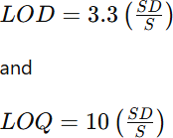

From the stock solution, various doses of Lenalidomide ranging from 2 to 4 µg/mL were produced and introduced into the system by injection. Table 5.9 lists the results that were obtained.System Suitability Test
System suitability tests were executed to assure chromatographic system’s proper functioning. Table 5.10 shows the results of analyses of previously prepared solutions under optimized chromatographic conditions.

Ruggedness
Ruggedness was checked by analyzing a 6 µg/mL Lenalidomide solution under the same experimental conditions by two different analysts. For solutions of the same concentration, determinations of peak area were made six times. The outcomes are given in Table 5.11.

Robustness
To test it, we tweaked the chromatographic parameters slightly and watched how the peak area changed. The analysis of a 6 µg/mL Lenalidomide solution was carried out in an experimental setting where the flow rate, constituents of the mobile phase, and temperature were varied. For each alteration, the analysis was carried out six times, and outcomes were recorded in Table 5.12.

Table 5.1: Optimization of Mobile Phase Composition also RP-HPLC Method Development
Sr.no | Mobile Phase | Proportion(%) | Flow rate | Retentiontime | Observation
 |  |  |  |  | Asymmetrical
1 | ACN: H2O | 80:20 | 0.8mL/min | 4.7 | peak with slight
 |  |  |  |  | tailing
2 | ACN: H2O | 70:30 | 0.8mL/min | 3.9 | Peak Splitting
3 | MeOH : H2O  (pH 9) | 80:20 | 0.7mL/min | 6.4 | Asymmetrical  peak
4 | MeOH: H2O  (pH 9) | 80:20 | 0.8mL/min | 4.1 | Asymmetrical  peak
5 | MeOH : H2O  (pH 9) | 80:20 | 0.8 mL/min | 5.5 | Asymmetrical  peak
6 | MeOH : H2O  (pH 9) | 80:20 | 1.0 mL/min | 4.7 | Asymmetrical  peak, less Rt
7 | MeOH : H2O  (pH 9) | 70:30 | 1.0 mL/min | 6.6 | Well resolved symmetric  peak

Table 5.2: Final Optimized Conditions for RP-HPLC method Chromatographic Mode Chromatographic Conditions HPLC System Agilent Tech. Gradient System (1100)

Detector
Data processor
UV (DAD) G13148 CHEMSTATION 10.1
Column Inertsil C8 column (5 µm)
Dimensions: 250 X 4.6 (in mm)
Mobile phase CH₃OH: H₂O(7: 3) pH 9
wavelength 395 nm
Rate 60.0 mL/hour
Inj. Vol. 20μL

Table 5.3: Linearity Studies

Conc.(μg/mL) | Average peak area ± SD | % RSD(n=5)
2 | 77379.67± 1333.66 | 1.72
4 | 163001.00± 3096.11 | 1.90
6 | 260331.33± 3258.40 | 1.25
8 | 356724.67± 4768.17 | 1.34
10 | 447256.00± 5385.10 | 1.20
12 | 555366.67± 6964.69 | 1.25
n- number of determinations

Table 5.4: Bulk determination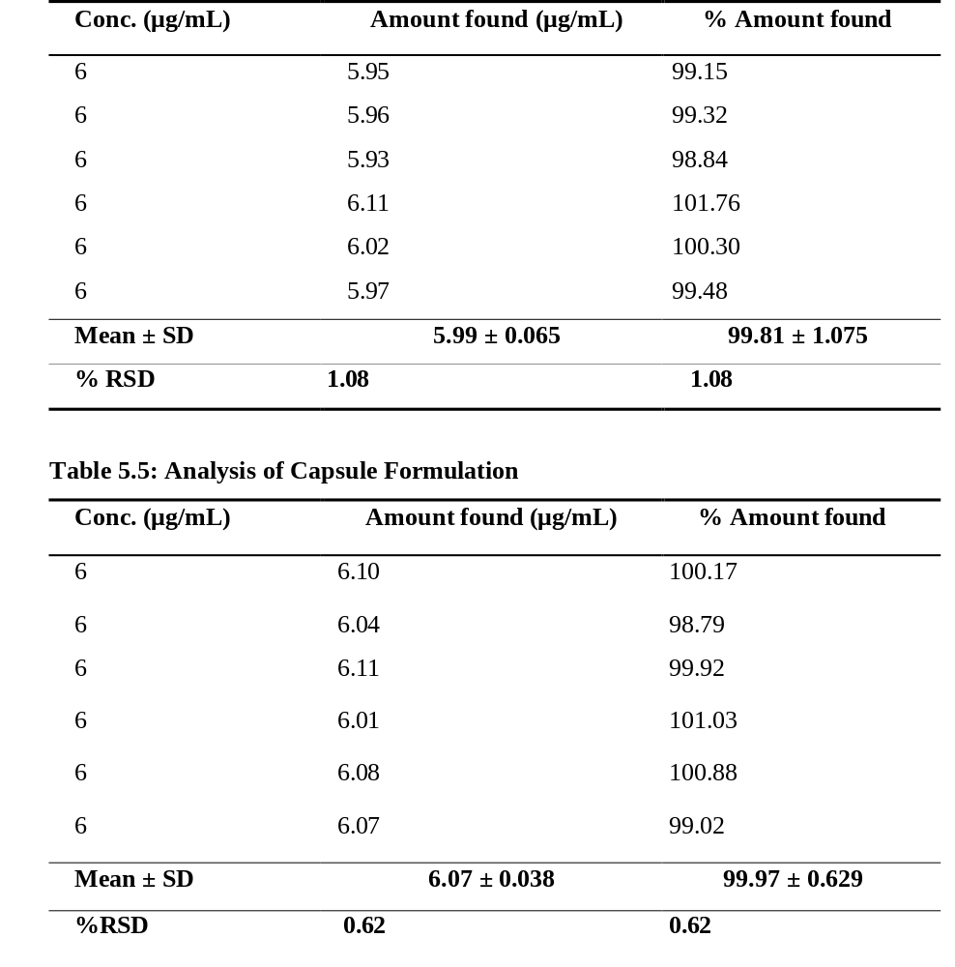

Table 5.6: Recovery Studies

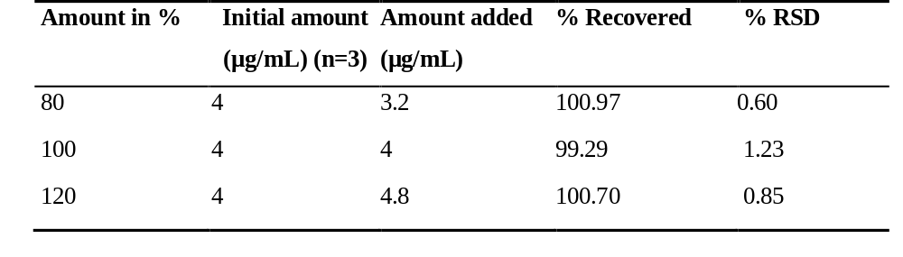
n- replicas
Table 5.7: Repeatability Studies

 | Conc. (μg/mL) | Amount found (μg/mL) | % Amount found
 | 6 | 5.92 | 100.82
 | 6 | 6.10 | 99.50
 | 6 | 6.07 | 98.88
 | 6 | 5.96 | 99.04
 | 6 | 6.00 | 100.37
 | 6 | 6.09 | 99.95
 | Mean ± SD | 6.02± 0.076 | 100.40±1.261
 | %RSD | 1.26 | 1.26
 | Table 5.8: Precision Studies

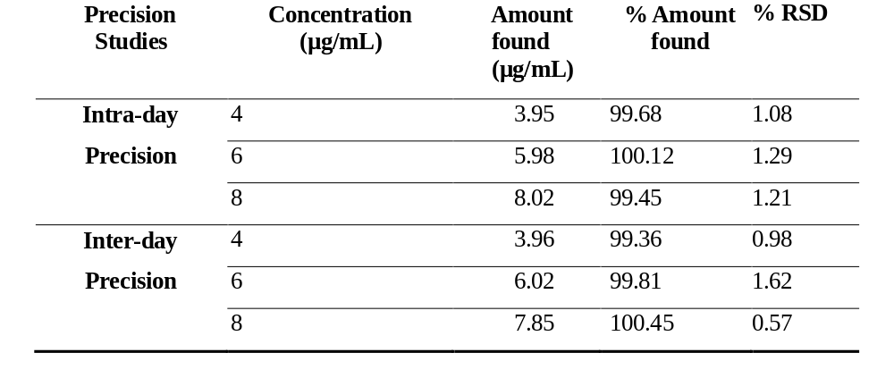
Table 5.9: Sensitivity Studies

LOD (μg/ml) LOQ (μg/ml)

0.13 0.39

Table 5.10: System Suitability studies



Table 5.11: Ruggedness Investigation

Conc. (μg/mL) | Approach | Observed (%) ± S.D. | %RSD [n=6]
6 | I | 98.93± 0.26 | 0.26
6 | II | 100.84± 0.75 | 0.74

Table 5.12: | Robustness Studies
Sr. No. | Parameter | % RSD
1. | Mobile phase composition  a) CH₃OH : H₂O (7.8: 2.2) | 0.11
 | b) CH₃OH : H₂O (8.2: 1.8) | 0.12
2. | Column Temperature (oC)  a) 32 | 0.23
 | b) 28 | 0.34
3. | Change in Flow Rate  a) 0.9 | 0.42
 | b) 1.1 | 0.26

Chromatograms showing trials :
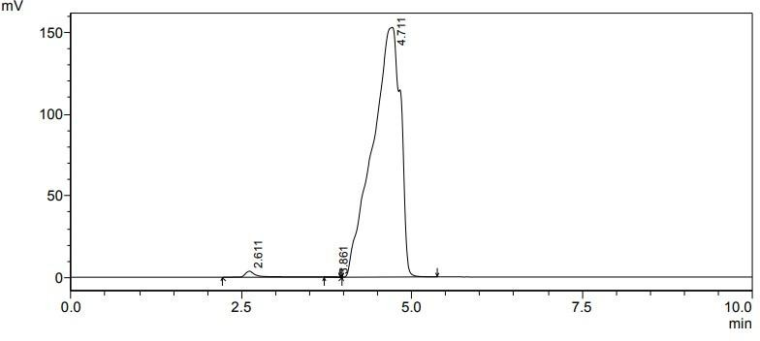
Figure 5.A.a: Trial I -Mobile phase composition ACN: H₂O (8:2)
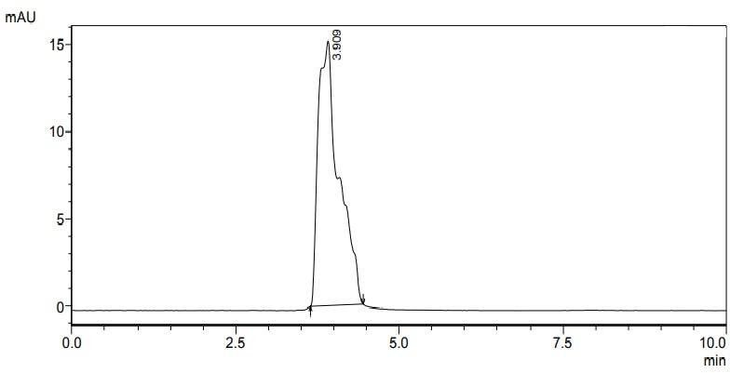
Figure 5.A.b: Trial II - Ratio CH₃OH: H₂O (70: 30 v/v)

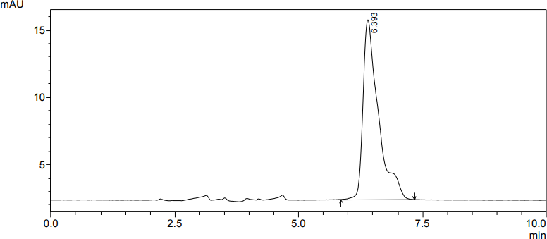
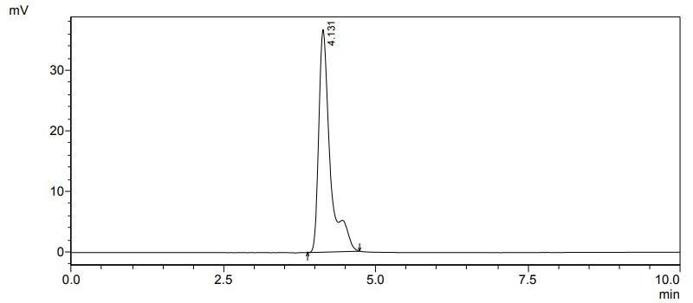
Figure 5.A.c: Trial III - Ratio CH₃OH: H₂O (80: 20 v/v)
Figure 5.A.d: Trial IV-Ratio CH₃OH: H₂O (80:20 v/v) (pH 9)

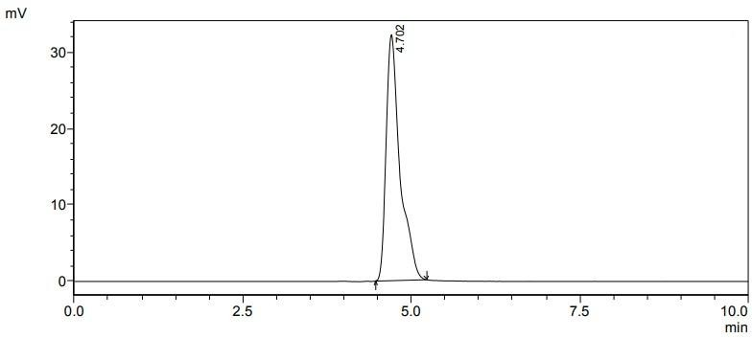
Figure 5.A.e: Trial V- Ratio CH₃OH: H₂O (70:30 v/v) (pH 9)
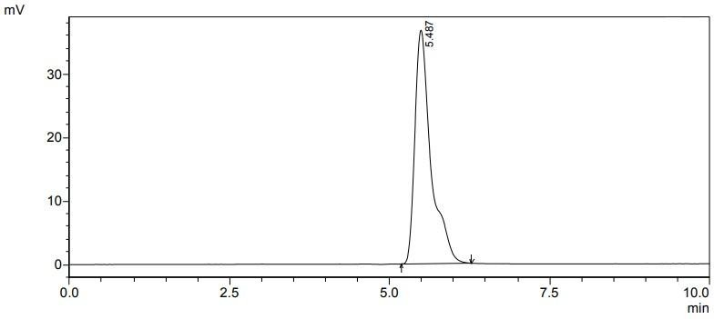
Figure 5.A.f: Trial IV-Ratio CH₃OH: H₂O (70:30 % v/v) (pH 9)

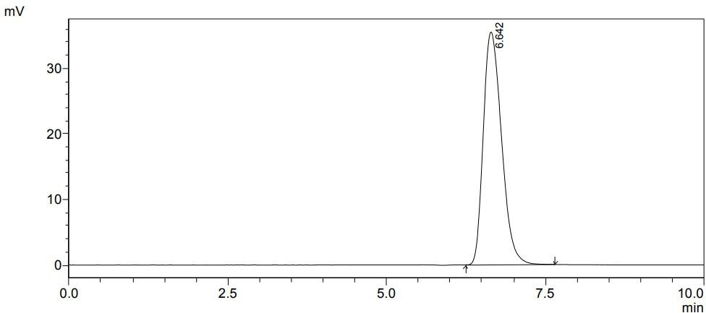
Figure 5.B: Chromatogram of Lenalidomide CH₃OH: H₂O (70:30 v/v) (pH 9)
Concentration (µg/ml)
14
12
10
8
6
4
2
0
0.00
y = 47701x - 23899
R² = 0.9991
600000.00

500000.00

400000.00

300000.00

200000.00

100000.00
Peak Area

Figure 5.C: Calibration Graph for Lenalidomide

5.2. Method 2: Establishment and Verification of a UV-Spectrophotometric Approach for Assessing Lenalidomide in Bulk and Tablet Preparations

Materials
Pharmaceutical-grade lenalidomide working standards were generously supplied by Natco Pharma Ltd., India. All analytical-grade reagents consumed in the investigation were acquired from Merck Chemicals, India. Commercially product Lenangio® tablets encompassing 10 mg of lenalidomide per tablet were procured from a local pharmaceutical market.

Experimental
Preliminary solubility studies and choice of solvent Selection of Solvent
Solvent choice was done subsequent to checking solubility of pure drug in various solvents and finally methanol was chosed as solvent for establishing spectral characteristics of Lenalidomide.

Stock Standard Solution of Lenalidomide
A stock of lenalidomide was created by dissolving 10 mg of the pure drug in CH₃OH in a clean and dry 100 cc VF to obtain a final 100 μg/mL concentration.

Determination of λ_{max}
To assess λ_{max} of Lenalidomide, the suitable dilution was produced from previously prepared stock solution. In particular, 1 cc of the concentrated solution was moved to a 10 cc volumetric flask also diluted to the final volume with CH₃OH to achieve the solution with the final 10 µg/CC concentarion. The solution was then scanned in the UVvisible spectrophotometer within the range 200-800 nm in UV spectrum mode. According to the UV spectrum, the wavelength of maximum absorbance (λ max) of Lenalidomide was determined as 395 nm, which was selected for the subsequent spectroscopic analysis. The zero-order UV absorption spectrum of Lenalidomide is represented in Figure 5.d.

Linearity Study
The method linearity was examined for Lenalidomide from concentration range of 10-60 µg/CC. Solutions of diverse concentrations were prepared and diluted by accurate pipetting 1.0-6.0 cc of solution in discrete 10 cc volumetric flasks with CH₃OH. The absorbance of diluted solutions was determined at the predetermined λmax of 395 nm against a blank solution. A curve was obtained by plotting absorbance observations against concentrations. The slope and intercept of the regression line and the corresponding SD were calculated. Calibration data and linearity curve are presented in Table 5.13 and Fig 5.e.

Analysis of bulk material
10 mg accurately weighed Lenalidomide was passed into 100 cc VF and solubilised in methanol by forceful shaking. The volume was then arranged to the Marq with the solvent. Dilution of 3 cc of this solution was made up to 10 cc with the same solution to get second solution. The solutions were then scanned utilising a UV Spectrophotometer at wavelengths of 400-200 nm again against the solvent as blank. The findings are as screened in Table 5.14 below.
Method Validation
The developed analytical approach was validated considering ICH instructions by evaluating key performance parameters, including linearity, accuracy, sensitivity, and ruggedness.

Accuracy
The method accuracy was checked utilising recovery findings at three concentrations: 80%, 100%, and 120%. An accurately measured quantity of standard lenalidomide was put to a pre-analyzed test solution containing 20 μg/mL lenalidomide, after which the mixture was reanalyzed using the progressed method. The outcomes of recovery studies validated the precision of the technique.
Precision
The method precision was estimated via repeatability evaluation, intra-day precision, and inter-day precision. Repeatability was confirmed by analyzing a solution of 30 μ g/mL of lenalidomide in triplicate, while intra-day precision experiments were carried out by three-time analysis of lenalidomide solution of 20, 30, and 40 μ g/mL on the same day. Moreover, the inter-day precision of the technique was estimated through the analysis of the same solutions with concentrations of 20, 30, and 40 μ g/mL of lenalidomide three times a day for 3 consecutive days. As an outcome, it was found that the newly developed method possesses good precision.

Sensitivity
The method’s sensitivity is determined by calculating the lowest conc. of the tested pesticide (LOD) and the level at that the tested pesticide can be reliably measured (LOQ). For the purpose of determining the mentioned parameters, diluted solutions (10-20 µg/ml) were used, followed by constructing a calibration graph. Thus, LOD and LOQ were computed in accordance to given formulas:
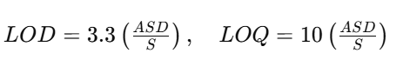
Where, ASD = avg SD of absorbance or peak area values (n = 3), considered as the determine of noise, and S denotes calibration curve slope. The “LOD” and “LOQ” values for lenalidomide were showed to be 0.50 μg/mL and 1.51 μg/mL, accordingly.

Ruggedness
Ruggedness of proposed method was tested by 2 different analysts treating the same model of UV spectrophotometer at the same operating conditions. The investigation was carried out at lenalidomide concentration of 30 μg/mL. As a result, it was found that the method is rugged and reproducible under routine laboratory conditions.
Table 5.13: Linearity Studies of Lenalidomide

Conc. of | Zero Order UV-Spectrophotometry | Method
Lenalidomide | Absorbance (Average) | % RSD
(μg/mL) | ± SD | [n=5]
10 | 0.165 ± 0.0015 | 0.90
20 | 0.323 ± 0.0021 | 0.64
30 | 0.515 ± 0.0030 | 0.59
40 | 0.684 ± 0.0033 | 0.48
50 | 0.870 ± 0.0058 | 0.67
60 | 1.026 ± 0.0062 | 0.39
n-number of determinations

Table 5.14: Analysis of Bulk API Drug
Conc.  (μg/mL) |  | Amt. found  (μg/mL) | % Amt. found
30 |  | 29.90 | 99.66
30 |  | 29.84 | 99.47
Lenalidomide 30 |  | 30.01 | 100.04
30 |  | 30.07 | 100.23
30 |  | 30.13 | 100.42
30 |  | 30.01 | 100.04
Mean ±SD |  | 29.99 ±0.10 | 99.96 ±0.35
% RSD |  | 0.35 | 0.35

n-number of repetitions
Table 5.15: Analysis of Capsule Formulation

Drug | Conc. (μg/mL) | Amount (μg/mL) | % Amount
 | 40 | 40.30 | 100.74
 | 40 | 40.24 | 100.60
 | 40 | 40.75 | 101.89
Lenalidomide | 40 | 40.18 | 100.46
 | 40 | 40.58 | 101.46
 | 40 | 39.95 | 99.89
 | Mean ± SD | 40.34± 0.29 | 100.84± 0.72
 | % R. S. D. | 0.71 | 0.71
n-number of repetitions

Table 5.16: Recovery Investigation

Drug | Initial amount  (μg/mL) | Amount added  (μg/mL) |  | Amount Recovered  (μg/mL) | %  recovery | % RSD [n=3]
 | 20 | 16 |  | 16.16 | 101.02 | 1.14
Method I | 20 | 20 |  | 20.03 | 100.15 | 1.72
 | 20 | 24 |  | 23.95 | 99.81 | 1.67
n- number of determinations
Table 5.17: Repeatability Studies
Drug Conc. (μg/mL) |  |  | Amount found (μg/mL) |  | % Amount found
30 |  |  | 30.13 |  | 100.42
30 |  |  | 30.30 |  | 100.99
PMD 30 |  |  | 30.30 |  | 100.99
30 |  |  | 30.47 |  | 101.56
30 |  |  | 30.47 |  | 101.56
30 |  |  | 30.41 |  | 101.37
Mean ± SD |  |  | 30.34± 0.13 |  | 101.15± 0.44
% RSD |  |  | 0.43 |  | 0.43

n-number of repetitions

Table 5.18: Precision Studies
Conc.
Amount found
% Amount
% RSD

(µg/mL) | (μg/mL) | found | [n=3]
Precision (Intra Day)
20 | 19.90 | 99.52 | 1.13
30 | 30.02 | 100.08 | 1.25
40 | 40.16 | 100.41 | 0.71
Interday Precision
20 | 19.78 | 98.91 | 1.33
30 | 30.46 | 101.52 | 1.05
40 | 40.71 | 101.77 | 0.95

Table 5.19: Ruggedness Studies

Parameters | [%] found (SD) | % RSD  [ n=6]
Analyst I | 100.93 (0.81) | 0.80
Analyst II | 98.96 (0.68) | 0.69

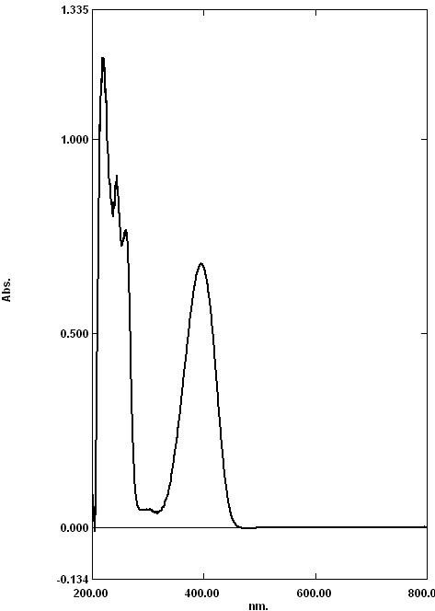
Figure 4.3.A: UV spectrum of Lenalidomide displaying λ max at 395.00 nm in Methanol
Zero order absorbance method
1.200
1.000
0.800
0.600
0.400
0.200
y = 0.0175x - 0.0142 R² = 0.9993
0.000
0
20
Conc(µg/ml)
40
60
80
Absorance

Figure 4.3.C: Standard Curve of Lenalidomide.

CHAPTER -5
REFRENCES

References

- A. K. Conners, Textbook of Pharmaceutical Analysis, 3rd ed.; A Wiley- Intersciences Publication, 1999, pp. 616.
- A. V. Kasture, S. G. Wadodkar, K. R. Mahadik, and H. N. More, Textbook of Pharmaceutical Analysis – II, 11thedn., Published By Nirali Prakashan, 1996, pp. 156- 165.
- Ağtaş, Ç. and Atici, E.B., 2025. Development and validation of stability-indicating UHPLC-UV-MS tandem methods for lenalidomide assay, related substances, and genotoxic impurity monitoring. Journal of Pharmaceutical and Biomedical Analysis, 258, p.116757.
- ALSHEHRT, M.M., Al-Ghorab, M.M., & Al-Shehri, M.M. (2016) ‘STABILITY- INDICATING CAPILLARY ELECTROPHORESIS METHOD WITH PHOTODIODE ARRAY DETECTOR FOR DETERMINATION OF LENALIDOMIDE IN
- Alzoman, N.Z., Sultan, M.A., & Al-Shehri, M.M. (2017) ‘A Validated Stability- Indicating and Stereoselective HPLC Method for the Determination of Lenalidomide Enantiomers in Bulk Form and Capsules’. Chirality, 29(1), pp. 19–27.
- Alzweiri, M., Sweidan, K. and Aqel, Q., 2022. Investigation of the Chemical Stability of Lenalidomide in Methanol/Ethanol Solvents Using RP-HPLC-UV and LC-MS. Jordan Journal of Pharmaceutical Sciences, 15(3), pp.305-314.
- Armoiry, X., Aulagner, G. and Facon, T., 2008. Lenalidomide in the treatment of multiple myeloma: a review. Journal of clinical pharmacy and therapeutics, 33(3), pp.219-226.
- B. K. Sharma, Instrumental Method of chemical Analysis, 21stedn., Goel publishing house, 2002, pp. 9-16.
- B. K. Sharma, Instrumental Method of Chemical Analysis, 21th ed., Goel Publishing Housing, 2002, pp. 3.
- B. K. Sharma, Instrumental Method of chemical Analysis, Goel Publishing Housing, Krishna Prakashan Ltd., 2002, pp. 3.
- C. D. Gary, Analytical chemistry, 5th edn. John Wiely& sons, Inc., 2001, pp. 1- 3.
- Cao, Z., Liu, T., Yan, X., & Liu, G. (2018) ‘Simultaneous determination of thirteen related substances in lenalidomide API by a stability-indicating RP-HPLC method’. Journal of Pharmaceutical and Biomedical Analysis, 151, pp. 297–304.
- D. A. Skoog, F. J. Holler and T.A. Nieman, Principles of Instrumental Analysis, 5th edn., Thomson Brook/cole, 2005, pp. 674-696.
- D. Skoog. J. Leqary. Principle of Instrumental Analysis. 54 thed. Thomson Asia PvtLtd.Singapore; 2004, 3-8.
- De Novellis, D., Raimondo, A., Serio, B., Baldi, C., Giudice, V., Lembo, S. and Selleri, C., 2024. Lenalidomide‐induced psoriasis in a refractory multiple myeloma patient successfully treated with narrowband ultraviolet B. Photodermatology, Photoimmunology & Photomedicine, 40(3).
- Demir, I., Yüce, M., & Dursun, Ö. (2023) ‘Development, validation, and greenness assessment of environmentally friendly analytical methods for the quantification of lenalidomide in pharmaceutical formulations’. Analytical Methods, 15(15), pp. 1957– 1968.
  - DNA binding studies of lenalidomide using spectroscopic in combination with molecular docking techniques. Journal of Molecular Structure, 1154, pp.9-18.
- E. Heftman, Chromatography- Fundamentals & applications of Chromatography and Related differential migration methods, 6thedn, Elsevier, Amsterdam, Vol. 69A, 2004,
- E. Heftman, Chromatography- Fundamentals & applications of Chromatography and Related differential migration methods,6thedn., Elsevier, Amsterdam, Vol. 69A, 2004, pp. 72-87.
- E. Katz, Quantitative Analysis Using Chromatographic Techniques, Wiley India Pvt. Ltd.: 2009, pp. 193 -211.
- E. Stahl, Thin Layer Chromatography: A Laboratory Handbook, 2ndedn, Springer International Edition, pp.1-30
- F. A. Settal., Handbook of instrumental techniques of analytical chemistry, 1st edition (2004) 19-21
- F. Settle, Handbook of Instrumental Techniques of Analytical Chemistry, 2004, pp. 19-21 609-617.
  - FORMULATIONS’. Asian Journal of Pharmaceutical and Clinical Research, 3(3), pp. 81–83.
- G. Christian. Analytical Chemistry. 5th ed. John Wiley and Sons, Inc. New York; 2001, 1-3.
- Guglieri-López, B., et al. (2016) ‘A wide linearity range method for the determination of lenalidomide in plasma by high-performance liquid chromatography: application to pharmacokinetic studies’. Therapeutic Drug Monitoring, 38(4), pp. 544–549.
- Gupta, A., et al. (no date) ‘Central composite design aided optimization and validation of developed an eco-friendly HPLC method for the quantification of Lenalidomide loaded mesoporous silica nanoparticles’. Journal of Pharmaceutical and Biomedical Analysis (Information regarding year, volume, issue, and page numbers not provided in original text).
- H. Beckett, J. B. Stenlake, Practical Pharmaceutical Chemistry, 4thedn., Part II, CBS Publications and Distributors, New Delhi, 1997, pp. 1, 275-300.
- H. Beckett, J. B. Stenlake, Practical Pharmaceutical Chemistry, 4th ed.; Part II, CBS Publications and Distributors: New Delhi, 1997, pp. 275-277.
- H. H. Willard, L. L. Merritt, J. A. Dean, and F. A. Settle, Instrumental Method for Analysis, 7th edn, CBS publishers and distributors, New Delhi, 1986, pp. 513-530.
- H. H. Willard, L. L. Metritt, J. A. Dean, F. A. Settal, Instrumental methods of Analysis, 7th ed., CBS Publishers and Distributers, 1986, pp. 118.
- International Conference on Harmonization (ICH), Q2A: Text on Validation of Analytical Procedure USFDA federal register, vol 60, May 1995 pp. 11260
- International conference on harmonization (ICH), Q2b: Validation of analytical procedure: Methodology, USFDA federal register, Vol. 62, May 1997, pp. 27463
  - International Journal of Research in Pharmacy and Chemistry, 5(2), pp. 353–359.
- Iqbal, M., et al. (2018) ‘Development and validation of ultra-performance liquid chromatographic method with tandem mass spectrometry for determination of lenalidomide in rabbit and human plasma’. Journal of Pharmaceutical and Biomedical Analysis, 154, pp. 20–27.
- J. Cazes, P. W. Scott, Raymond, Chromatography Theory, Marcel Decker, Inc, NY, 2002, pp. 443-454.
- J. Swadesh, HPLC –Practical and Industrial Applications–CRC Press, Boca Raton, 1997,
- K. A. Connors, Liquid Chromatography- A Textbook of Pharmaceutical Analysis, 3rd edn., Willey Interscience, New York, 1999, pp. 373-438.
- Kalpan, K., Sanyal, M., & Kumar, R. (2020) ‘A Simple and Rapid LC-MS/MS Method for Therapeutic Drug Monitoring of Lenalidomide’. Biomedical Chromatography, 34(7),
- Kazakevich Y., Introduction to HPLC process [serial online]. Available from URL:http://hplc.chem.shu.edu/NEW/Graduate/Modern.Sep.2006/Lect.%201%20Intro%2 0 (2-day).ppt
- Kotla, V., Goel, S., Nischal, S., Heuck, C., Vivek, K., Das, B. and Verma, A., 2009. Mechanism of action of lenalidomide in hematological malignancies. Journal of hematology & oncology, 2, pp.1-10.
- L. R. Synder, J. J. Kirkland, L. J. Glajch, Practical HPLC Method Development, 2ndedn., John Wiley & sons, Inc, 1997, pp. 21-57, 653-660.
- Li, S., Gill, N. and Lentzsch, S., 2010. Recent advances of IMiDs in cancer therapy. Current Opinion in Oncology, 22(6), pp.579-585.
- P. D. Sethi, HPTLC: Quantitative Analysis of Pharmaceutical formulation, 1stedn., CBS Publications, New Delhi, 1996, pp.162-165.
- P. D. Sethi, Introduction – High-Performance Liquid Chromatography, 1stedn, CBS Publishers, New Delhi, , 2001, pp.1-28.
  - p. e4860.
- P. W Scott, Raymond, Encyclopedia of Chromatography, 10th edn., Marcel Dekker, Inc. USA, 2001, pp. 252-254.
- P. W. Scott, Liquid Chromatography Column Theory, John Willey and Sons, Chi Chester, 2001, pp. 1-13.
- Patel, M., Patel, H., & Patel, P. (2014) ‘Method development and validation of degradation studies of lenalidomide by RP-HPLC’. International Journal of Pharmaceutical Sciences and Research, 5(8), pp. 3442–3448.
- Payab, M., Zarghi, A., & Shokri, J. (2014) ‘Development of a reversed-phase HPLC method for determination of related impurities of Lenalidomide’. Research in Pharmaceutical Sciences, 9(4), pp. 273–279.
  - PHARMACEUTICAL PREPARATION’. Analytical Chemistry Letters, 6(3), pp. 317– 334.
- Ponnuru, B., Rao, P.G., & Rao, G.L. (2020) ‘Development and Validation of Stability Indicating Rp-hplc Method for Quantitative Estimation of Lenalidomide in Lenalidomide Capsules Dosage Form’. International Journal of Pharmaceutical Quality Assurance, 11(1), pp. 109–116.
  - pp. 20-25.
  - pp. 253-291.
  - pp. 917–929.
- R. D. Brawn In: Introduction to instrumental analysis. Pharma book syndicate, Hydrabad, (2006) 1-7
- R. D. Brawn, In: Introduction to instrumental analysis. Pharma book syndicate, Hyderabad, 2006, pp. 1 - 7.
- Raghu, N.S., Kumar, N.K., Rao, K.S., & Ramachandran, D. (2013) ‘DEGRADATION STUDIES OF HIGHLY POTENT AND LIFE-THREATENING HUMAN BIRTH DEFECT DRUG LENALIDOMIDE BY HPLC AND LC-MS’. Chromatographia, 76(23-24), pp. 1667–1679.
- Rao, B.M., Rao, D.V., & Rao, G.L. (2009) ‘Development of an HPLC Assay Method for Lenalidomide’. Journal of Liquid Chromatography & Related Technologies, 32(11), pp. 1651–1661.
- Reddy, L.B., Kumar, N.K., Rao, V.S., & Ramachandran, D. (2012) ‘Development of a Rapid and Sensitive HPLC Assay Method for Lenalidomide Capsules and Its Related Substances’. Journal of Chemistry, 2013, pp. 1–7.
- Reddy, R. et al. (2013) ‘Degradation Studies of Highly Potent and Life-Threatening Human Birth Defect Drug Lenalidomide by HPLC and LLC-MS’. Chromatographia, 76(23-24), pp. 1667–1679.
- Reviewer Guidance, Validation of Chromatographic Methods (CDER), Nov.1994
- Sastry, B.S., Reddy, S.P., & Rao, S.S. (2010) ‘NEW SPECTROPHOTOMETRIC METHODS FOR ESTIMATION OF LENALIDOMIDE IN PHARMACEUTICAL
- Saxena, J., & Jain, S. (2022) ‘Development and Validation of an Environmentally Benign and Robust Stability Indicating Assay Method for Lenalidomide: Comprehensive Degradation Kinetics Study and Application’. Journal of Pharmaceutical Analysis, 12(6),
- Saxena, J., Saroj, S. and Rajput, S., 2017. Estimation of lenalidomide in bulk and its dosage form using uv spectrophotometric and Rp-Hplc methods. Indo American journal of pharmaceutical research, 3, pp.7938-7945.
- Shabir, G.A., 2003. Validation of high-performance liquid chromatography methods for pharmaceutical analysis: Understanding the differences and similarities between validation requirements of the US Food and Drug Administration, the US Pharmacopeia and the International Conference on Harmonization. Journal of chromatography A, 987(1-2), pp.57-66.
- Shirman A, Khan GJ, Ansari YA, Qazi S, Inamdar ZE, Siddiqi H, Syed UF, Syed T, Syeda S. DEVELOPMENT AND VALIDATION OF ANALYTICAL METHOD FOR QUANTITATION OF CLOFARABINE. Indian Drugs. 2022 Jan 1;59(1):60.
- Sitamahalakshmi, D.S.V.N., Kumar, A.N., & Rao, G.L. (2019) ‘Stability Indicating RP- HPLC Method for Quantitative Estimation of Lenalidomide and Its Impurities in Solid Dosage Form’. Journal of Analytical Chemistry, 74(9), pp. 770–778.
- Swathi, K., & Madhusudan, B. (2015) ‘METHOD DEVELOPMENT AND VALIDATION FOR THE QUANTITATIVE ESTIMATION OF LENALIDOMIDE IN API FORM AND MARKETED TABLET DOSAGE FORM BY RP-HPLC’.
- Tageja, N., 2011. Lenalidomide-current understanding of mechanistic properties. Anti- Cancer Agents in Medicinal Chemistry-Anti-Cancer Agents), 11(3), pp.315-326.
- U S pharmacopoeia 24, Validation of compendia methods, section <1225>, united states pharmacopeialconvension, Rockville, MD, 1999, pp. 2149
  - US pharmacopoeia 23, Chromatography section <621>, united states Pharmacopeial Convension, Rockville, MD, 1994, pp. 1776
- Vardhan, G., Singh, S., & Singh, R.P. (2022) ‘Development and validation of a novel chiral chromatographic method for the separation of lenalidomide enantiomers in human plasma’. Journal of Separation Science, 45(15), pp. 2707–2713.
- Venkateshwarlu, P., Patel, M., & Patel, H. (2014) ‘Method development and validation of degradation studies of lenalidomide by RP-HPLC’. International Journal of Pharmaceutical Sciences and Research, 5(8), pp. 3442–3448.
- Vogel’s Text book of quantitative chemical analysis, 5th edn., Longman Group UK Ltd., 1989, pp. 1-5.
- www.camag.com
- Xu, L., Hu, Y.X., Li, Y.C., Zhang, L., Ai, H.X., Liu, Y.F. and Liu, H.S., 2018. In vitro
- Y. Anjeneyulu, K. Chandrasekhar, V. Manikam. A textbook of Analytical Chemistry. Pharma Book Syndicate; 2005, 3-10
- Yang, B., Yu, R.L., Chi, X.H. and Lu, X.C., 2013. Lenalidomide treatment for multiple myeloma: systematic review and meta-analysis of randomized controlled trials. PLoS One, 8(5), p.e64354.
